Surgery Clerkship

Dr. Gayle Minard, Clerkship Director

cell: 901-201-0669

office: 901-448-8370

Room 212, 910 Madison

email: gminard@uthsc.edu

Assistant Clerkship Director

Pending

Ms. Courtney Bishop, Clerkship Coordinator

office: 901-448-8370

Room 214, 910 Madison

email: cbishop@uthsc.edu

Dr. David Shibata, Chairman of Surgery

Website: http://www.uthsc.edu/surgery/clerkship.php

IMPORTANT CONTACTS FOR EACH ROTATION

Regional One Health – Prior to assignment date, get an ID badge from Security located on the 1st floor Chandler (Carolyn Witt 545-7700). Go to TTC on your first day at 7 AM. Resident pager is 242-9870.
Methodist University Surg Onc – For a badge, go to the Medical Education Department, 251 S. Claybrook, 2nd floor. Please contact the chief resident.
Methodist University Acute Care/Minimally Invasive Surgery - For a badge, go to the Medical Education Department, 251 S. Claybrook, 2nd floor. Please contact the chief resident.
Methodist Germantown Surg Onc - For a badge, go to the Medical Education Department, 251 S. Claybrook, 2nd floor. Please contact the chief resident.
VA – See Colette Scott (523-8990, ext. 2123) room CW353, 3rd floor. Must complete mandatory online training.
Baptist General Surgery – Page the chief resident. Also, need to see Regina in MedEd for badges, etc. 226-3843.
Baptist Minimally Invasive Surgery - Page the chief resident. Also, need to see Regina in MedEd for badges, etc. 226-3843.
Cardiothoracic (CT) Baptist – Please contact Dr. Garrett (pager: 524-8430 or office: 747-1249). Also, need to see Regina in MedEd for badges, etc. 226-3843.
Cardiothoracic (CT) VA – See Colette Scott (523-8990, ext. 2123) room CW353, 3rd floor. Must complete mandatory online training. Then contact Dr. Darryl Weiman, pager 577-7288 (6524) or office 2123.
Vascular Methodist – Page resident (418-5599) or Dr. Rohrer (392-3195). For a badge, go to the Medical Education Department, 251 S. Claybrook, 2nd floor.
Vascular VA – See Colette Scott (523-8990, ext. 2123) room CW353, 3rd floor. Must complete mandatory online training. Then page Dr. Bridgette Ostrow, 577-7288 (1107), office 6975
LeBonheur – Page Peds fellow 269-0208. Also, contact Amber Stroupe at 287-6300 for a badge and handbook.
Transplant – Page Dr. Nezakatgoo (351-3998). For a badge, go to the Medical Education Department, 251 S. Claybrook, 2nd floor.
Neurosurgery at Semmes-Murphey – 6325 Humphreys Blvd. Go to the front desk where patients check-in and ask for Gail Woods. She will direct you to Dr. Michael.

SURGERY OBJECTIVES

Surgery Clerkship Objectives

Conduct a focused history and physical appropriate for the particular surgical disease and accurately assess and interpret the findings.

List demographics that increase the risk of certain surgical diseases, such as breast cancer, lung cancer, hepatoma among others

Use available data, including laboratory and imaging results, to formulate appropriate management plans.

Perform basic surgical skills, including preoperative preparation and routine postoperative care, suturing and knot tying in collaboration with the healthcare team.

Describe standard procedures in surgical practice that are intended to minimize adverse outcomes, such as infections and medical errors.

Recognize altered structure and function, pathology, and pathophysiology of the body and its major organ systems as seen in common surgical diseases.

Through observation and direct involvement, learn to communicate effectively with patients and their families to empower shared decision-making. Apply these skills to diverse patient populations.

Through observation and direct participation, work effectively with the health care team to optimize patient outcomes, including consideration of tradeoffs between risks and benefits.

Conduct daily responsibilities in a manner that reflects the scope of responsibility that a surgeon assumes for patients, families, and referring physicians.

OVERVIEW OF THE CLERKSHIP

The 8 week surgical clerkship is composed of a two week Regional One Health (ROH) rotation on general surgery and trauma, along with a 2 week subspecialty rotation of pediatrics, cardiothoracic, vascular or transplant. The second month will be a month general surgery rotation at Baptist, Methodist University, Methodist Germantown, or the VA. Most of that time is spend on inpatients, but clinics are available and patients are expected to attend.

During the two week rotation at ROH, the student will take trauma/acute care surgery call every third day with their team, alternating day call with 24 hour call. If working with the CCA consult resident, the hours will be 7A to 7P. Call at the other hospitals will be “prn”. Let your attending residents know if you want to be called for cases.

There are several labs including suturing, knot tying and airway. There is an extensive interactive lecture series given by the faculty. In addition, students are expected to go to the Wednesday resident conferences including Grand Rounds and basic Science. These lectures and conferences are REQUIRED and take priority over clinical care.

Recommended Texts/Reading list

NMS
Sabiston Textbook of Surgery (paperback)
Schwartz’s Principles of Surgery (paperback)
Greenfield’s Surgery: Scientific Principles and Practice (paperback)

NON-ROH RESPONSIBILITIES

You are responsible for patient care on the floors. Each patient should be assigned to a student who will then follow the patient for his or her whole hospitalization. On your first day on the service, the group should obtain a list of patients and divide them evenly. New patients should be assigned as they are admitted/operated on, and will need a history and physical. Daily progress notes should be written for all patients.

Please notify a member of the team as soon as you note any problems or abnormalities with your patients--don't wait until the next scheduled rounds.

A student should scrub for his/her patients' surgical procedures. This is important for your education, will assist you in their post-op care -- plus, it's the most exciting part of surgical care.

Follow patients in the ICU.

ROH GENERAL SURGERY/TRAUMA RESPONSIBILITIES

All third-year students will rotate on the ROH trauma/general surgery rotation for two weeks, spending the entire time being with one of three teams. Each student will spend a 12 ish hour day on general surgery, followed by either a 12- or 24-hour day on trauma, followed by a day off. There is no specific general surgery team on Friday, Saturday or Sunday so the trauma team on call those days will cover all patents/cases and the other teams are off. Trauma pagers should be obtained from Ms. Bishop. After orientation on the first day of the surgery rotation, find your team (even if a team is “off” as they may be in clinic or conference) and introduce yourself to the Attending, Fellow (if on a trauma day), chief, TICU resident and the CCA resident (attendings will change frequently). From then on, contact your team AT LEAST the day before the rotation starts, but you will likely be told to meet them the next morning in the TTC for turnover rounds. Responsibilities will be as follows:

GENERAL SURGERY
Mornings start at 7 AM in the TTC for turnover rounds (except Wednesdays when turnover rounds are at 6:30). Students should attend all surgeries and clinics scheduled on their general surgery day. Unless a lecture or lab is scheduled, at least one student should scrub on every case.

TRAUMA
Mornings start at 7 AM in the TTC for turnover rounds (except Wednesdays when turnover rounds are at 6:30 AM). Students will carry a trauma pager and their responsibilities are:
1. Come to all Shock Trauma 1’s with your team and perform tasks such as
a. cut off clothes
- draw femoral vein VBG’s and blood (required)
- start IV’s (required)
- insert Foley catheters (required)
- insert NG and/or OG tubes (required)
- perform and interpret FAST exam (required)
- put in chest tubes (with significant supervision)
- apply splints (in conjunction with orthopedics)
- interpret labs and radiographs
- accompany critically ill patients to CT/angio if all/part of your team is doing so
- Scrub in on all operative trauma cases but students may also scrub on subspecialty if desired. If so, let the team know and contact them once the case is over.
2. May evaluate trauma consults at CCA in conjunction with second year surgery resident
a. perform and document additional history and physical in conjunction with trauma CCA resident
- assist in ordering and evaluate any further labs and radiographs
- place chest tubes, NG/OG tubes, arterial lines, Foley catheters, IV’s when necessary and appropriate
- evaluate and treat wounds including suturing (required)
- Accompany patients to the operating room.
- Follow patient in CCA that are admitted to the trauma service without a bed yet available.
- May also be assigned to go to Shock Trauma 2’s with the CCA consult resident.

TRAUMA OR
  - Unless a lecture or lab is scheduled, at least one student should scrub on every general trauma case but may scrub on subspecialty if desired. If so, please inform your team and check back in with them when that case is over.
2. Intubate elective patients (required)

Specific daily duties will be proscribed by the fellow or chief.

(CRITERIA SHOCK TRAUMA 1 - HR > 130 (> 110 for geriatric patients), HR < 50, SBP < 90 (< 100 for geriatric patients), airway compromise, all intubated patients, GCS <= 12, penetrating injury to head, neck, chest, torso, extremity trauma / amputation proximal to knees/elbows or if tourniquet is in place. Positive FAST, neurologic deficit or suspected spinal cord injury, pelvic fx, or hip dislocation, receiving blood to maintain vital signs, CCA physician judgment)

(CRITERIA SHOCK TRAUMA 2 - significant MOI (fall >10 feet, pedestrian or cyclist struck, MCC, rollover MVC), significant penetrating wound to extremity, suspected multiple fractures or open fractures, altered mental status with trauma, pregnancy > 20 weeks without other factors above, femur fracture, known TBI on anticoagulation, CCA Physician judgment)

The third year students are not orderlies or nurse substitutes. They are there to learn how to manage trauma patients, not push stretchers or administer medications. However, if trauma is extremely busy, it is understood that ANYONE may need to perform tasks that are not usually in their job description.

General Surgery rotations: what to expect, study, who to contact etc.

For specific details, I.e. time of AM & PM rounds, meetings, etc., text the resident on service. Oftentimes, time of AM rounds will be determined the evening before based on number of patients on service, morning conferences, etc.

Baptist General Surgery Oncology (Dr. Monroe)
- Residents: Intern, 5th year (contact)
- Rounds: Rounds are completed in the morning before cases. Help get the vitals and lab values for the rounding list. A lot can be learned by looking at the trends and what subtle changes turn out to be important in patient care
- Surgery: oncology cases but also including general surgery. Read about the cases prior as much of the teaching will occur intraoperatively. Especially knowing TMN staging, workup, pathophysiology and anatomy. Work on knot tying and suturing skills for skin closure
- Clinic: see patients and write notes, work on focused H&P skills

Surgical Oncology at Methodist University
- Residents: Intern, 3rd year, 5th year (contact)
- Rounds: Rounds are completed in the morning before cases. The intern and 5 round and the 3 and 5 round. Help get the vitals and lab values for the rounding list. A lot can be learned by looking at the trends and what subtle changes turn out to be important in patient care
- Surgery: oncology cases but also including general surgery. Read about the cases prior as much of the teaching will occur intraoperatively. Especially knowing TMN staging, workup, pathophysiology and anatomy. Work on knot tying and suturing skills for skin closure
- Clinic: see patients and write notes, work on focused H&P skills

Surgical Oncology at Methodist Germantown (Dr. Dickson)
- Residents: 3rd year, 4th year, 5th year (contact)
- Rounds: Rounds are completed in the morning before cases. The PGY3 and 5 generally round at Germantown and the 4 is at Baptist
- Surgery: oncology cases but also including general surgery. Read about the cases prior as much of the teaching will occur intraoperatively. Especially knowing TMN staging, workup, pathophysiology and anatomy. Work on knot tying and suturing skills for skin closure
- Clinic: see patients with residents, work on focused H&P skills
- GI malignancy conference: 06:30 Tuesday morning at West Clinic

VA General Surgery
- Residents: Intern, 2nd year, 4th year, 5th year (contact)
- Rounds: Rounds are completed in the morning before cases and conference. The PGY1 is responsible for comprehensive care of the floor patients, while the PGY2 is responsible for the ICU patients. The rounding list will be updated with labs and vitals prior to rounds.
- Surgery: General surgery cases, including colorectal, biliary, hernia, acute care, feeding access. Etc. Read about the cases prior as much of the teaching will occur intraoperatively. Work on knot tying and suturing skills for skin closure
- Clinic: see patients and write notes, work on focused H&P skills

ACS at Methodist University
- Residents: Intern, 2nd year, 4th year (contact)
-Rounds: Rounds are completed in the morning before cases and conference. The PGY1 is responsible for comprehensive care of the floor patients, while the PGY2 is responsible for the ICU patients. The rounding list will be updated with labs and vitals prior to rounds.
- Surgery: General surgery cases, including colorectal, biliary, hernia, acute care, feeding access. Etc. Read about the cases prior as much of the teaching will occur intraoperatively. Work on knot tying and suturing skills for skin closure
- Clinic: see patients with residents, work on focused H&P skills

MIS at Baptist/Methodist Germantown (Dr. Webb/Stoikes)
- Residents: Intern, 2nd year (contact)
- Rounds: Rounds are completed in the morning before cases. The PGY1 is responsible for the floor patients and PGY2 is responsible for the ICU patients. Usually have cases and patients in the hospital at both hospitals. The rounding list will be updated with labs and vitals prior to rounds
- Surgery: General surgery cases, including colorectal, biliary, hernia, acute care, etc. Majority of cases of laparoscopic. Read about the cases prior as much of the teaching will occur intraoperatively. Work on knot tying and suturing skills for skin closure
- Clinic: see patients with residents and work on focused H&P skills. Clinic is Monday-Thursday afternoons

Trauma
Current chiefs
A-Whatley, B-Staszak, C-Ulm, Chief pager – 242-9852
Turnover conference
07:00 daily, except 06:30 Wednesdays (conference) in TTC. Students generally sit on the right of the room during turnover. Review presentations, pertinent imaging, and plans of admitted patients. Good time to learn management of trauma patients. Listen especially for cases for the day to scrub. Following turnover, the chief and floor doc will do floor rounds, 3rd year does TICU rounds and 2nd year does CCA turnover. Either go to OR for cases or round.
OR
The chief will have scheduled cases during the day, usually take back ex laps from the TICU, tracheostomies, skin grafts, etc. One medical student should always be scrubbed in cases. Emergency trauma cases are unpredictable, but students should attend all shock traumas, and go with the chief to the operating room for operative traumas.
Shock Trauma
Medical students should attend all shock traumas. They are announced by page. Try to be an efficient member of the trauma team. Watch the first couple to get the hang of the flow. Everyone has a designated role. Gauge the severity of the patient’s situation and get involved accordingly. Traditional roles for students have been exposing the patient, helping turn the patient in spine precautions, US/FAST, placing nasogastric tubes for intubated patients, placing foley catheters, covering the patients with blankets to avoid hypothermia. Students are not limited to these roles, and oftentimes students will perform arterial sticks and femoral blood draws. Assess the patient’s severity, and offer to assist in other ways if interested.
CCA
Medical student roles in CCA are changing, but in general, follow the pgy2’s lead. Trauma patients in CCA require assessment similar to patients in shock trauma, albeit in a slower fashion. Assist and observe the pgy2 with assessments and procedures. If a CCA patient goes to the OR, a medical student should go scrub their case.
TICU
Trauma ICU patients can be complicated, but can be a great learning opportunity. The pgy3 is very busy, and will appreciate help from students. Some ways to be helpful might be changing dressings on rounds, recording chest tube or drain outputs, removing chest tubes or lines, making sure supplies are at the bedside for an anticipated procedure, etc.
General tips
Show interest. Study during downtime. Be prepared to answer basic anatomy questions during cases. Try to be helpful, and integrate yourself into the trauma team. Take turns with your fellow students. Take initiative. When rounding, help change dressings, etc. Ask questions. The more you can help the residents and save a bit of time, the more time they have to teach. This is a terrific operative experience. The residents will try to include the students as much as possible, but students have to be aware of cases, either by asking the chief, or watching the OR board, or paying attention in CCA/shock trauma.

Other Electives:
Peds Le Bonheur
- Residents: Intern, 2nd year, 4th year, Fellow (contact)
Vascular VA
Vascular at Methodist University
- Residents: Intern, 3rd year (contact)
CT surgery at Baptist
-Second
Transplant Surgery at Methodist University
- Residents: Intern, 3rd year (contact)
Neurosurgery with permission
ENT with permission
Urology with permission
Orthopedics with permission
PRS with permission

GRADING

CLINICAL 45%
Each student is assessed by the surgical faculty and residents based upon patient management, responsibility, fund of knowledge, participation, and reliability. Students should be able to form a differential diagnosis and initiate basic workup and treatment. The professional code is also used as an assessment tool. The student must receive a passing grade in order to pass the course. A copy of the final evaluation on New Innovations is attached.

WRITTEN EXAM 40%
A shelf exam from the National Board of Medical Examiners will be administered only at the time and date listed. If you fail the test, you will receive an R (retake) and you must retake it after meeting with the clerkship Director UNLESS you also fail the oral exam (see below). If you fail the written test a second time, you will receive a grade of "F" for the clerkship. You must achieve at least the 50th percentile (for the comparable quarter) in order to qualify for an “A” for the entire clerkship.

ORAL EXAM 15%
A faculty and/or a senior surgical resident will present 2 case studies for a focused history, physical, appropriate differential diagnosis, workup and management. If you fail the oral exam, further action will depend on the results of the written exam. If you fail both the written and the oral exams, you will receive an "F" for the course. If you pass the written test, you will be able to retake the oral exam with a different faculty member. Failing the orals twice will result in a final grade no higher than a “B”. The orals are scored by two methods. First, the examiner gives a numeric score based on their subjective impression of the student’s ability to explain a focused history, physical, differential, workup and treatment. The examiners also check off a scoring rubric to give a more objective score (similar to OSCE and the CS exams). These two scores are averaged.

Mid-month feedback is required; failure to return will result in an incomplete. Completion of NG/FAST checklist card, 4 focused H&P cards, hours and diagnoses logs on eMedley are also required. Failure to complete any of these in a timely fashion (one week after completion of the clerkship) will result in an email from the clerkship director and a notification of the Assistant Dean of Students. After one month, an incomplete grade will be submitted to the registrar and the student’s grade will be reduced one whole letter grade. After two months, the student will receive a grade of “F” for the course. Although the Hall S. Tacket evaluation is not required, it is highly encouraged and is very useful feedback for the rotation. Please complete it through Qualtrics.

STUDY GUIDE

ACUTE PANCREATITIS

Discuss the pathophysiology and etiologies of acute pancreatitis
What is the differential diagnosis of acute pancreatitis?
What are the important components of treatment?
Discuss pseudocyst formation and treatment.
What are the indications for surgical intervention in this disease?
Discuss hemorrhagic pancreatitis and Ransom's criteria.

APPENDICITIS
Discuss the pathophysiology and etiologies of acute appendicitis.
What is the differential diagnosis of acute appendicitis?
What are the important components of treatment?
What are the differences between somatic and visceral pain?
What is direct/indirect rebound, psoas, and Rovsing's sign?

BREAST CANCER

What is the differential diagnosis of a breast lump?
What are the important questions/risk factors in the history and physical?
What is the role of mammography/biopsy in a breast lump?
What are the treatment modalities in breast cancer?
What is the role of chemotherapy and radiotherapy in this disease?

GASTRIC ULCER

Pathophysiologically, how does gastric differ from duodenal ulcer?
Describe the medical management of gastric ulcer.
What are the indications for surgery for gastric ulcer?
What is the typical location for gastric ulcer and gastric cancer?

ANORECTAL DISEASE
Describe the symptoms, signs, diagnosis, treatment, and etiology of the following:
Hemorrhoids
Anal fissure
Pilonidal abscess
Perirectal abscess/fistula

JAUNDICE
Explain the pathophysiology of jaundice.
Discuss the interpretation of liver function tests.
Describe the radiology of liver diseases and jaundice.
Tell how to perform a workup for obstructive or cellular jaundice.

COLON CANCER
What is the difference in presentation between left and right sided colon cancer?
What is the significance of villous and adenomatous polyps to cancer?
Describe the Dukes' Classification and prognosis.
How does colon cancer spread? What operation is done for cecal cancer? sigmoid cancer?
What is the role of chemotherapy and radiotherapy in colon cancer?

PULMONARY INFECTIONS
Describe the physiologic mechanisms involved in movement of fluid from the parietal to the visceral pleura and explain the pathologic and physiologic changes that result in excessive accumulation of pleural fluid.
List the stages of empyema formation.
Correlate the type of surgical treatment of empyema with the stage of disease.
Contrast medical versus surgical infection utilizing pneumonia and empyema as an example.

ESOPHAGUS
Describe the basic anatomy and functional physiology of the esophagus.
Explain the pathophysiology of esophageal motor disorders.
Correlate esophageal symptoms with their abnormal physiologic state.
Explain the medical and surgical treatment of motor disorders.
Describe the basic defense mechanisms of the esophagus that prevent abnormal reflux.
Discuss the physiologic bases for medical and surgical treatments of reflux disease of the esophagus.

INFLAMMATORY BOWEL DISEASE
Contrast mucosal colitis with transmural colitis.
Discuss the diagnosis and treatment of fulminating colitis.
Compare the alternatives in the surgical treatment of mucosal colitis.
Discuss the diagnosis and treatment of small bowel Crohn's Disease.
Contrast the medical treatment of ulcerative colitis with that of Crohn's.

VENOUS DISEASE
Define DVT and tell why it occurs in the surgical patient.
Relate pathophysiology to symptoms of DVT/PE.
Identify high-risk patient categories.
Relate etiology to prevention.
Describe the diagnostic methodology used for venous disease, DVT, and PE.
Describe and justify the therapies currently used for these conditions.

PORTAL HYPERTENSION
Name the most common cause of portal hypertension in the USA.
Describe the pathophysiology of portal hypertension.
List the clinical manifestations of portal hypertension.
Tell how you would manage a patient with variceal bleeding.
Describe the difference between a total and a selective shunt.
Describe the Child's classification of functional hepatic reserve.
Explain the medical and surgical treatment of ascites.

BURNS
Clinically differentiate first, second, and third degree burns.
Describe fluid replacement for significant burns.
What is the significance of myoglobinuria and how is it treated?
What is the indication for escharotomy?
Describe signs and symptoms of an airway burn.

PEDIATRIC SURGERY
Tell how to perform a differential diagnosis of an abdominal mass.
Tell how to perform a diagnostic workup.
Describe these prognostic factors:
Wilms Tumor
Neuroblastoma
Hepatoblastoma

SURGICAL INFECTIONS
Importance of host, bacterial colonization, and nutritional media for producing surgical infections.
Name those risk factors that are relatively immunosuppressive and predispose a patient toward sepsis.
Explain the microbiology of surgical infection.
List and justify the principles of prophylactic use of antibiotics.
Describe the rationale for empiric antibiotic therapy in the management of surgical sepsis.
The importance of surgical debridement and abscess drainage in the management of surgical sepsis.

SEPSIS/SEPTIC SHOCK
Relate pulmonary artery occlusion pressure to left ventricular and diastolic volume.
Tell how septic shock changes cardiac output and systemic vascular resistance.
Define and differentiate "infection," "sepsis," and "septic shock."
List and define the types of shock.
Describe and justify the therapy for septic shock.

PEPTIC ULCER DISEASE
List the indications for surgical treatment.
Describe the alternatives in surgical treatment.
Explain the expected recurrences/complications of surgical treatment.
Explain the physiological bases for the various tyupes of surgical treatment.

TRAUMA AND SHOCK
Be able to describe the 1° and 2· assessment.
Know the signs, symptoms, and Rx for immediate life threatening injuries
Cardiac tamponade
Tension pneumothorax
Ruptured aorta
Open pneumothorax
Be able to discuss the 4 types of shock and resuscitation for each
Hypovolemic
Cardiogenic
Neurogenic
Septic
Be able to describe the 4 classes of hemorrhagic shock.

SURGICAL NUTRITION
Be able to discuss the metabolism of stress and starvation.
Understand the following principles:

Protein needs for stressed and/or malnourished patients
Calorie:nitrogen ratio
Glucose/fat requirements
Determining nutrition prescriptions for patients

Refeeding syndrome
Discuss the benefits of enteral versus parenteral feeding.

PERIPHERAL VASCULAR DISEASE
Appreciate history of vascular surgery.
Understand signs and symptoms that suggest peripheral arterial disease (both obstructive and aneurysmal).
Understand the noninvasive evaluation of the vascular patient.
Understand the basic operative procedures in peripheral vascular surgery.

ACQUIRED HEART DISEASE
Understand the pathophysiology of acquired heart disease, which mnay lead to mechanical complications, which require surgery.
Know the pathophysiology of cardiac tamponade, its signs and diagnosis by:
Physical examination
Echocardiography
Intracardiac pressure measurements
Know the techniques for relief of cardiac tamponade:
Outside the hospital
In the emergency department
Definitively
Know the general "indications for surgery" and "risk: benefit ratios" for valvular and atherosclerotic heart disease and cardiac transplantation.

CUTANEOUS LESIONS
Be able to recognize and describe the natural history for the skin keratoses including actinic keratoses, seborrheic keratoses, and keratoacanthoma.
Describe the appearance, natural history, and management of cutaneous squamous cell carcinomas and basal cell carcinomas.
Describe the appearance of the warning signs for melanoma; understand the histological staging of melanoma and its significance for prognosis; outline the surgical management of melanoma.

TRANSPLANTATION
Understand the success rate of the major solid organ transplants.
Explain the facts regarding brain death and the associated pathophysiological abnormalities.
Explain the facts regarding the process of identification and consent for organ donation.
Explain the clinical and technical variations in the anatomy of organs that would affect procurement procedures.
Explain the long-term outcome of transplantation procedures.
Understanding of basic mechanisms of action of immunosuppressants.

HERNIA
Understand the embryology, anatomy and pathophysiology of hernia development.
Understand the rationale for the repair of inguinal and ventral hernias.
Be able to formulate a differential diagnosis of a groin or scrotal mass.
Be able to discuss the meaning of direct vs. indirect hernias and incarceration vs. strangulation.
Be familiar with the most common types of hernia repairs and the etiology of recurrences.

WOUND HEALING
Principles of primary wound closure/suturing to optimize healing/wound strength and minimize scar.
Contraindications to wound closure.
Name 3 disease states which automatically result in increased wound healing complications and why.
What amount of bacteria in a wound (to the nearest log of 10) produces wound infection?

SURGICAL SKILLS (MUST BE PERFORMED ON PATIENTS NOT MANNEQUINS)

Required Skills
Draw Blood
Insert IV
Insert NG/OG
Perform and Interpret ABG/VBG
Insert Foley
Abdominal History, Exam (can submit on card)
Read Chest x-ray
Read abdominal x-ray
Read CT - basic
Comprehensive breast exam (can submit on card)
Comprehensive vascular exam (include
ABI) (can submit on card)
Comprehensive rectal exam (include
prostate) (can submit on card)
Airway management
Oral/nasal airway
Orotracheal intubation
Focused abdominal ultrasound for trauma (FAST)
Tie knots/suture simple lacerations
Scrub, gown, and glove
Sterile technique
Universal precautions
Write SOAP notes
Remove drains, change dressings
Removal sutures, staples

Optional
Chest tube insertion
Central line insertion
Bronchoscopy

POLICIES (see links)

Professional Behavior/Code of conduct
Work hours
Mistreatment
ROH lockers and trauma beepers
Scrubs
Accessing VA computers
Security
Shuttle service
Inclement weather
Injuries and exposure to blood and body fluids
Duty hours/ patient logs
Excused absences/Wellness days
Lockers/pagers

MISCELLANEOUS

GENERAL GUIDELINES FOR PROFESSIONAL BEHAVIOR AND CONDUCT

The clinical rotations in the third year of medical school place demands and requirements on the students that go significantly above and beyond academic achievement as measured by performance on tests and by the ability to field questions learned through didactic instruction and reading. The student also is accountable for his or her behavior in each of the following areas:

• Professional and Ethical Conduct
The welfare of patients and their families is of foremost concern. Students must show respect and courtesy for patients and their families, even under difficult situations such as being challenged or provoked. Students must safeguard their patients' confidentiality. There are to be no casual communications regarding patients in public places, such as hallways, elevators, cafeterias, gyms, etc.

• Punctuality, Responsibility and Reliability
Students are expected to be available and present for all scheduled clerkship activities. Any absences must be approved by the clerkship director in advance. Make-up assignments will be determined by the clerkship director; absences due to illness may require a physician's statement. Chronic tardiness is unacceptable. Students are expected to conform to the prevailing schedule at the sites where they are assigned for their clinical instruction.

• Getting Along With Other Members of The Medical Team
Good relationships with nurses, aides, ward clerks, security personnel, and anyone else involved in the care of the patient are absolutely essential. Students are expected to be courteous to all medical staff at the sites where they are assigned for their clinical instruction. Please be sure to introduce yourself to the faculty and residents on the service.

• Getting Along With Staff
Students need to be polite and respectful to people other than the patients, faculty and residents, and hospital employees. Much of the daily work in keeping a clerkship going falls on the shoulders of administrative assistants, secretaries, receptionists, and other staff. Students are expected to be considerate of and courteous to all of these employees.

• Getting Along With Peers
Students are expected to have pleasant working relationships with their fellow students. This includes an equitable sharing of the workload and helping and supporting each other.

If the clerkship director receives consistent complaints about a student in any of these areas, the student's grade may be affected. Serious documented problems with unprofessional or unethical behavior, in the judgment of the clerkship director, may result in a failing grade even if the student has passed the written or oral examinations and has otherwise satisfactory clinical ratings. Also, consistent or serious complaints about unprofessional or unethical behavior may be reflected in the Dean's Letter.

There may be times when any student has a personal problem or a personality conflict that impairs his or her ability to function properly on the clerkship. It is the student's responsibility to promptly notify the clerkship director when this first occurs and not wait until after the fact.

Code of Professional Conduct

The University of Tennessee medical community believes that professionals gain their credibility by their commitment to society. As a professional group, we recognize our obligation to our patients, colleagues, community, families, and ourselves. Realizing that it is a privilege and an honor to be a medical professional, we the students, residents, fellows, and faculty of the UT Memphis College of Medicine embrace the following ideals:

- Patient welfare is our primary concern, for only by commitment do we justify the trust placed in us by patients and the community at large. Although we hold the acquisition of knowledge and the development of technical skills essential to patient care, we shall strive to balance the science with the art of medicine by maintaining respect and compassion for the dignity of all patients. Each patient shall receive our best efforts regardless of personal feelings or biases. Desires for social or economic gain shall not affect the honesty and integrity with which we deal with patients. Nor shall the pressures placed upon the members of our profession compromise the quality of care we provide.
- Relationships with our colleagues are an exceedingly important part of professional conduct. Our interactions with colleagues provide us a sense of support, trust, and sharing. As members of a professional community, we shall be aware that our personal conduct reflects upon others of that community. Professionalism includes being respectful in our communications and behavior toward colleagues and others. We shall avoid comments and actions that might reasonably be perceived as offensive or demeaning by others. This applies also to communications on web-based social media and other electronic media.

- We shall be willing to share our knowledge and expertise with colleagues and remain open to their advice and criticism. We shall know our own limitations and ask for advice when needed. We shall fulfill our own responsibility and, in the spirit of professional cooperation, accommodate a colleague if our assistance is requested. We shall be sensitive to the physical and emotional weaknesses of a colleague and shall lend support in time of need. Further, our responsibility to patient care implies identification of colleagues whose ability to provide care is impaired. This must be followed by our full support toward the rehabilitation of those colleagues, and their reintegration into the professional community.

- Integrating personal growth into our professional development is essential to our commitment to medicine. To this end, we shall be attentive to our needs for physical, spiritual, and emotional well being. We shall allow time for personal and family relations which enrich our lives and promote self knowledge. Attention to personal maturation, family commitments and professional growth represent a continuing challenge throughout our career.
- As medical professional, we realize that we share with all citizens certain civic duties. We shall strive to be responsible citizens. Our professional status shall not be used as a means to power and control. Rather, we seek to offer informed and compassionate leadership.

MEDICAL STUDENT DUTY HOURS POLICY

To address the time commitment required of medical students during clinical rotations and taking into account the effects of fatigue and sleep deprivation on learning, clinical activities, student health and safety, and patient safety, the College of Medicine has adopted the following policy.

- Duty hours will be limited to 80 hours per week averaged over a four-week period, inclusive of all in-house call and patient care activities. This does not include lectures, labs and conferences.

- Continuous on-site duty, including in-house call, will not exceed 30 consecutive hours. Students may remain on duty additional hours to participate in transferring care of patients, conducting outpatient clinics, maintaining continuity of medical and surgical care, and attending required didactic activities.

- Students will be provided with one day in seven free from all educational and clinical responsibilities, averaged over a rotation, inclusive of call. One day is defined as one continuous 24-hour period free from all clinical, didactic, and administrative activities.

- Students should be provided with a 10 hour period after in-house call during which they are free from all patient care activities.

Approved by the Committee on Undergraduate Medical Education, August 13, 2007.

Student Mistreatment

The policy on student mistreatment has three main components: a statement of College of Medicine standards of behavior with regard to mistreatment, a description of methods used in the ongoing education of the college community concerning the standards of behavior and the process by which they are upheld, and a description of the College of Medicine process for responding to allegations of mistreatment. The statement of College of Medicine standards of behavior with regard to mistreatment is as follows: The University of Tennessee College of Medicine has a responsibility to foster in medical students, postgraduate trainees, faculty, and other staff the development of professional and collegial attitudes needed to provide caring and compassionate health care. To nurture these attitudes and promote an effective learning environment, an atmosphere of mutual respect and collegiality among teachers and students is essential. While such an environment is extremely important to the educational mission of the College of Medicine, the diversity of members of the academic community, combined with the intensity of interactions that occur in the health care setting may lead to incidents of inappropriate behavior or mistreatment. The victims and perpetrators of such behavior might include students, preclinical and clinical faculty, fellows, residents, nurses, and other staff. Examples of mistreatment include: sexual harassment; discrimination based on race, gender, religion, ethnic background, sexual orientation, handicapped condition, or age; and purposeful humiliation, verbal abuse, threats, or other psychological punishment. Such actions are contrary to the spirit of learning, violate the trust between teacher and learner, and will not be tolerated by the College of Medicine. To promote an environment respectful of all individuals, the College of Medicine will provide ongoing education to students, residents, fellows, faculty, and other staff emphasizing the importance of professional and collegial attitudes and behavior. Also, the college will make available a readily accessible neutral party (called a mediator) whom students may approach if they believe they have been mistreated. A process has been established to seek reconciliation between the parties in cases of alleged mistreatment. This process seeks to protect the accuser from retaliation and to protect the rights of all parties involved in a complaint. Through these efforts, the college will maintain an atmosphere essential to its educational mission in the training of physicians. To mistreat is to treat in a harmful, injurious, or offensive way.

For example:

- to speak insultingly or unjustifiably harshly to or about a person
- to belittle or humiliate
- to threaten with physical harm
- to physically attack (e.g., hit, slap, kick)
- to require to perform personal services (e.g., shopping, baby-sitting)
- to threaten with a lower grade for reasons other than course/clinical performance.

Individuals wishing to discuss possible violations of these policies should contact the College of Medicine Office of Student Affairs at (901) 448-5684. All inquiries will be held in strict confidence. Accusations of racial or gender discrimination or harassment are referred to the UTHSC Affirmative Affairs Director. Disputes over grades are handled in accordance with College of Medicine academic policies. Additional information regarding the Mistreatment Policy and procedures can be found on the Student Affairs website: http://www.uthsc.edu/Medicine/StudentAffairs/

What should one do if mistreatment or abuse occurs?

- When an allegation of mistreatment occurs, the parties directly involved should first try to resolve the matter themselves. Many incidents are amenable to resolution. In some situations, however, this informal approach might be hindered by reluctance of the accuser to approach the accused. In such cases, a more formal alternative process is available for resolving the matter through the “Mediator.”

The role of the mediator, as the name implies, is to mediate between the conflicting parties and strive for reconciliation. It is anticipated that the mediator’s assistance will result in the resolution of most cases brought to her/his attention. If a reasonable effort on behalf of the Mediator does not yield a solution or the accuser or the accused is not satisfied with the results obtained through the Mediator’s efforts, the Mediator may contact the Conflict-Resolution Council to help resolve the case.

- The Conflict-Resolution Council will assess the evidence as objectively as possible, be fair in its deliberations, and protect the rights of the accused and accuser. It is the function of this council to decide whether the matter should be brought to the attention of the Dean.

- When it is the Dean’s judgment that a violation of university policy has occurred, the accused will be put on notice that he/she has violated such policy, and appropriate action will be taken.

Confidentiality and Protection from Retaliation

Every effort will be made to protect alleged victims of mistreatment from retaliation if they seek redress. Although it is impossible to guarantee freedom from retaliation, it is possible to take steps to try to prevent it and to set up a process for responding to it. To help prevent retaliation, those who are accused of mistreatment will be informed that retaliation is regarded as a form of mistreatment. Accusations that retaliation has occurred will be handled in the same manner as accusations concerning other forms of mistreatment, using the mediator and council if needed.

RELIGIOUS ACCOMMODATION POLICY

POLICY: The University of Tennessee Health Science Center acknowledges the diversity of its students and respects the rights of students to observe their religious beliefs and practices. UTHSC will endeavor to provide reasonable accommodations relating to religious beliefs and practices in response to a formal written student request. However, accommodations cannot be guaranteed in instances where such would create an undue burden on faculty, a disproportionate negative effect on other students who are participating in the scheduled educational activity, or jeopardize patient care.

PROCEDURE: Students beginning new programs or courses of study in a particular college will be advised by that college as to college-, program- or course-specific procedures that should be followed to obtain an accommodation for religious practices or observances. Students are encouraged to be proactive in reviewing college-, program- and course-specific assignments/activities in advance of matriculation/registration to determine whether these requirements might in some way conflict with their religious beliefs, practices or observances. Should such conflicts be in evidence, students should discuss possible options with the appropriate college official or faculty member. Reasonable accommodations may not be feasible in instances where there is a direct and insurmountable conflict between religious beliefs or observances and requirements of a given program.
It is the student’s responsibility to make arrangements with the course instructor or clerkship/experiential director as soon as possible, but no less than 30 days in advance of the religious holiday during which the student is requesting to be absent. It is also the student’s responsibility to meet all course obligations. Such requests are required for any and all educational activities scheduled for the date(s) in question, e.g. classroom exercises, laboratory assignments, exams, clinical/experiential assignments, etc. Finally, students are obligated to abide by the policies and procedures on religious practices and observances of any given patient-care institution (i.e., hospital, clinical setting) in which they are completing a portion of their educational experience. If a potential conflict between a student’s religious beliefs, practices or observations and institutional policy is identified, the student is to bring such to the attention of the clerkship/experiential director as soon as possible.

It is the course instructor or clerkship/experiential director’s responsibility to negotiate with a student the parameters of reasonable accommodations. The accommodations should be no more difficult than the originally scheduled activity or assignment. Instructors or experiential directors are not obligated to provide materials or experiences to students that would not normally be provided to all other students. In the event a student and instructor or clerkship/experiential director cannot reach an agreement regarding reasonable accommodations, the student may request a review of the request by a designated college official. The decision of the designated college official will be final.

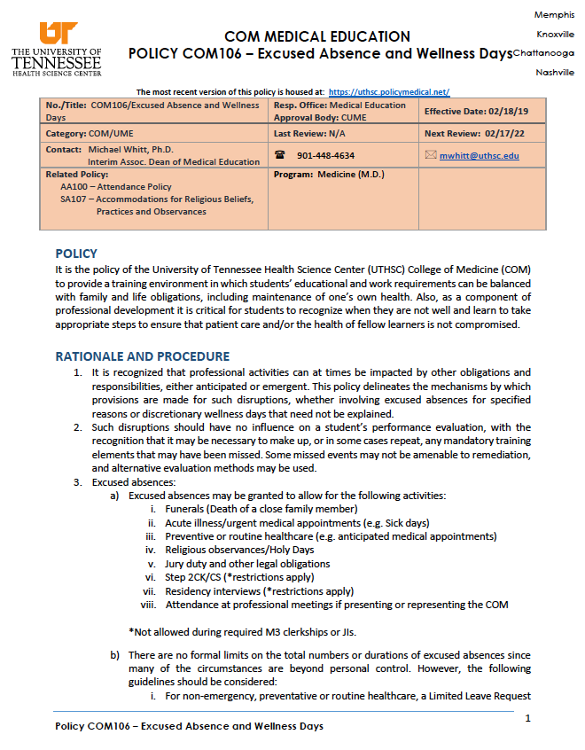
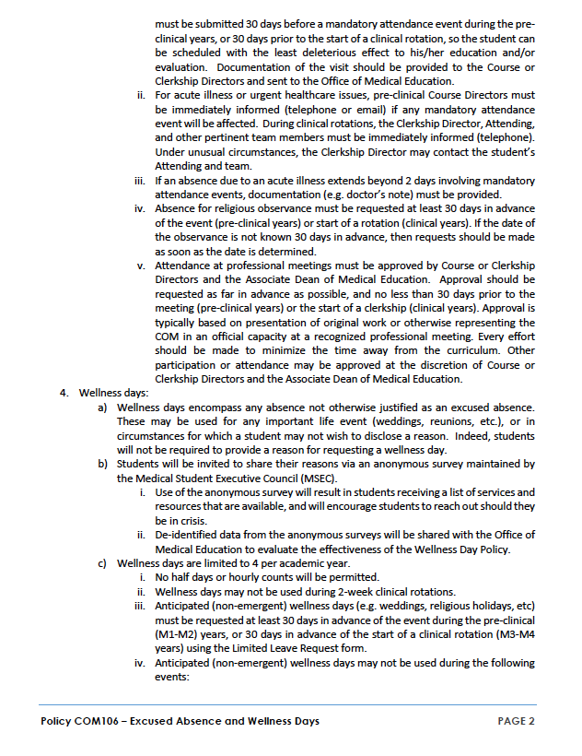
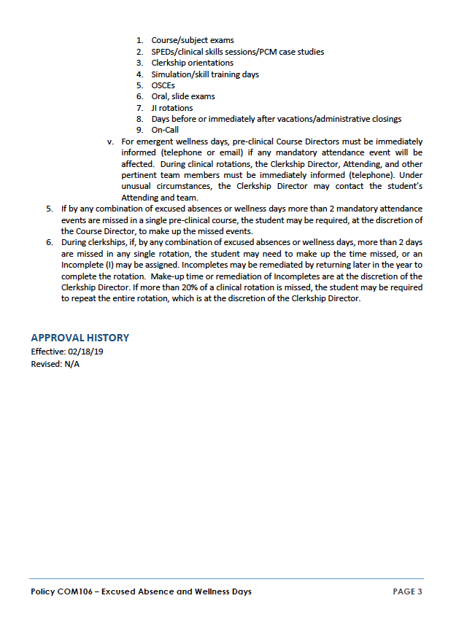
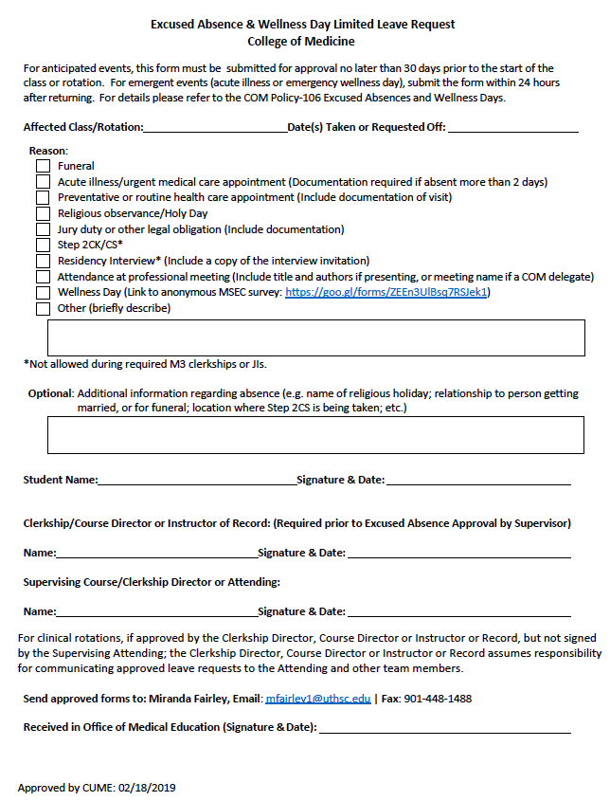

ROH LOCKERS AND TRAUMA BEEPERS

Please do not leave any valuables in any unprotected area in ANY hospital, which includes doctors lounges, etc.

Lockers are available in ROH in the Trauma Training Center on the ground floor of the Jefferson building. Please remove your lock when your rotation has finished.

Beepers are available for the students at ROH and can be obtained from Courtney Bishop, in room 214, 910 Madison. Students will share between night and day shift. DO NOT LEAVE PAGERS SOMEWHERE TO BE PICKED UP.

The pagers must be checked out and returned to Ms Bishop, not turned over to the next team.

Failure to return pagers to Ms Bishop will result in a fine of $50.00 (donated to the ROH Foundation).

If I cannot easily determine who lost the pager, each student who was sharing it will be assessed a $50.00 fine.

SCRUBS

After you receive a Regional One Health ID badge, please do the following to receive scrubs:

- Go to ROH intranet
- Under departmental, select Laundry Services
- Then complete the scrub request
- Be sure to use cbishop@uthsc.edu as the email address. NOT your own.

If you have problems with your access code, please contact Brenda Wells at 901-545-7990.

Requirements for accessing VA computers:

VA computers can be accessed by badge only, and most of the units are also transitioning to PIV cards for access. This means any resident, student, or associated health trainee wanting to participate in patient care must have a fully functioning badge (called a PIV badge) and PIN (four or six digit personal identification number). This requirement comes from Homeland Security, and there is nothing the local VA can do about it. Here is what you need to do:

- If you already have a badge, please drop by the VA and make sure your badge works BEFORE your rotation starts. If you have forgotten your PIN, which is required for badge use, drop by Police Service to reset your PIN.
- If you do not have a badge and have been fingerprinted within the last 120 days at the VA, contact your badge sponsor (see sponsor list below) to see if your badge is ready to be picked up. Then pick your badge up from Police Service and make sure it works for computer access.
- If you do not have a badge and have not been fingerprinted within the last 120 days, contact your sponsor and come to Police Service for your fingerprints. You are encouraged to walk in during the new extended hours of 6-8 a.m. and 4-7 p.m. Monday - Friday and 8 a.m. – 1 p.m. Saturday. You must bring two forms of identification with you such as birth certificate, SS number, passport or state driver’s license. One of these should be a picture ID. Check with your sponsor if you are unsure if your IDs meet requirements. Ask when to return for your badge.
- For any problems that may arise - and these are likely- contact Elston Howard at 523-8990 Extension 7395 or your sponsor. Given the urgency of the situation, watch for further updates in the overall process as we attempt to respond to this directive.
We apologize for this sudden, unexpected requirement. Email me for problems or complaints.

Jim Lewis, MD
Associate Chief of Staff for Education
901-523-8990 Extension 7819
James.Lewis319e9a@va.gov

Sponsors

Education Elston Howard 577-7395 Elston.Howard@va.gov
Pamela Armstrong 523-8990 5045 Pamela.Armstrong2@va.gov
Surgery Colette Scott 523-8990 2123 Colette.Scott@va.gov

OVERNIGHT SHUTTLE SERVICE
Shuttle available for medical students on call.
The GME shuttle is available from 6:00 pm to 6:00 am seven days a week to transport residents, medical students, and COM faculty within the Medical Center which includes the Pauline Garage, the MED, VA, Lebonheur, and Methodist University.
There will be a minivan that is stationed outside of the Pauline Garage. When exiting the garage, please show your UT ID, and the driver will take you to one of the four hospitals. When you need to be picked up and taken to the garage or another hospital, call Campus Police at 448-4444 and state that you are requesting the GME Shuttle. You must be at one of the designated areas listed at the bottom of the email. The driver will come to the location you specified, check your ID, and then take you back to the garage or other hospital location. Three guards were hired for the shuttle, and they will be dressed in uniform with UT logos. The names of the drivers are Marilyn Ivory, LaShone McLemore, and Nocomis Jones.
This shuttle is separate from the escort service that is provided by Campus Police.

Predetermined Pickup Locations:

Pauline Garage Entrance
Lebonheur-Main Entrance on Dunlap and Emergency Room Entrance

MED-Emergency Room Entrance and Rout Delivery Entrance
VA-Main Entrance and Emergency Room Entrance
Methodist University-Emergency Room Entrance

Clerkship Inclement Weather Policy
–
The administration of each campus decides when that campus is closed due to inclement weather.
Closure indicates that classes and scheduled meetings are cancelled.
In the event that the school is closed, faculty and students with clinical responsibilities are professionally obligated to provide that care even during inclement weather. Students on clinical services are expected to continue to provide care for their patients, provided traveling would not place the student at serious risk of injury.
Students should consult with their resident and physician supervisors to determine the risks/benefits involving travel during these periods.Students who are unable to travel to the rotation sites should contact the clerkship director and the team as soon as possible to advise them of the individual situation and whether the student could reach the site later in the day.

INJURIES & EXPOSURES TO BLOOD/BODY FLUIDS

What should I do if I am exposed?

If you are exposed to someone's blood, body fluids or other potentially infectious materials -- DO NOT IGNORE THIS EXPOSURE!!

Here are the steps you should take:

- Take appropriate first aid measures (clean wound with soap and water; flush mucous membranes with water/saline for 15 minutes)
- Get the name, medical record number and location of exposure source
- Notify your supervisor/preceptor so he/she can complete the Tennessee First Report of Injury and mail it to Risk Management within 48 hours
- Report, in person, to University Health Services ® 910 Madison Ave, Suite 922.
- If exposure occurs after hours, call 901-448-5630 to get the provider on call. It is very important that you are seen at University Health Services if possible, to prevent any charges from other facilities.

