The Coronavirus Aid, Relief, and Economic Security Act (“CARES Act”) of 2020 requires the university to provide timely reporting of compliance with the distribution of the Higher Education Relief Fund (“HEERF”) to provide emergency financial aid grants to students for expenses related to the disruption of campus operations due to the coronavirus.
- The University of Tennessee Health Science Center acknowledges that the institution signed and returned to the U.S. Department of Education the Certification and Agreement and the institution intends to use no less than 50 percent of the funds received under Section 18004(a)(1) of the CARES Act to provide Emergency Financial Aid Grants to students.
- The total amount of funds that the institution will receive from the Department pursuant to the institution’s Certification and Agreement [for] Emergency Financial Aid Grants to Students is $499,039.
- The total amount of Emergency Financial Aid Grants distributed to students under Section 18004(a)(1) of the CARES Act as of September 30, 2020 is $480,850.
- The total number of eligible students by aid year is 2,766 for 2019-2020 and 2,564 for 2020-21, calculated only by the number of institutional student information records received.
- As of May 1, the university estimated 2,603 students at the institution were eligible to participate in programs under Section 484 in Title IV of the Higher Education Act of 1965 and thus eligible to receive Emergency Financial Aid Grants to students under Section 18004(a)(1) of the CARES Act.
- As of September 30, 2020, 987 students have received an Emergency Financial Aid Grant to students under Section 18004(a)(1) of the CARES Act.
- The university awarded the grants to students in three distinct groups. First, the neediest students who are defined as the Federal Pell Grant recipients, were awarded $250. The second group of students were identified by institutional records as students who were unable to complete as expected but had to extend their enrollment due to the disruption, were each awarded $500. The third group of students submitted an application defining educational expenses for which grants funds were requested, due to the disruption, were awarded in accordance with the application submitted, in order of application submission date and fund availability.
- Instructions, directions, and guidance was provided by the institution to students concerning the emergency financial aid grants. The following email was sent to all 2,603 students on May 1, 2020:
Dear UTHSC Students,
The COVID-19 disruption has created unexpected educational expenses for some students. Federal grant dollars are available to assist students who incurred additional educational expenses due to the disruption. Examples of additional expenses may include:
- technology that you had to purchase to continue classes online,
- additional food or housing expenses for room and board,
- transportation costs if you had to return from an intended learning location in order to continue your studies, and
- additional course materials you required to remain engaged in your studies.
The federal grants are cash grants to students, focused on helping you now. These grants do not require repayment. Federal guidance has defined that the grants are not estimated financial assistance and will not affect other financial aid you’ve received this year. The federal emergency grant amount may exceed your cost of attendance.
You may submit a one-time application for the federal grant to assist with the educational expenses you incurred. Be prepared to identify the type of expense and the amount. Applications will be reviewed weekly. Depending upon the situation, we might ask you for additional information or documentation.
To apply for the federal student grants, go to Banner Self-Service > Financial Aid > Surveys > Emergency Student Grant Application. Applications will be reviewed weekly and grant notifications will be sent to UTHSC emails.
Only students who completed a 2019-2020 Free Application for Federal Student Aid (FAFSA) and demonstrated eligibility for federal student aid are qualified for the federal student grants. UTHSC is reviewing federal guidance carefully and working quickly to award the grants to qualifying students with eligible expenses.
If you are awarded a federal student grant, it will come to you through your student account (direct deposit). However, if you currently have a balance due on your student account, the emergency grant will not be applied towards those charges. Any student with a balance due will receive their awarded federal student grant by check which will be sent to their current mailing address.
If you have questions, please contact Financial Aid at onestop@uthsc.edu or 901.448.7703.

Sincerely,
Darrylinn D. Todd, Ed. D
Associate Vice Chancellor
Enrollment Management
University of Tennessee Health Science Center

- The online application was available to students via the Banner Self-Service student portal:
- https://banner.uthsc.edu/
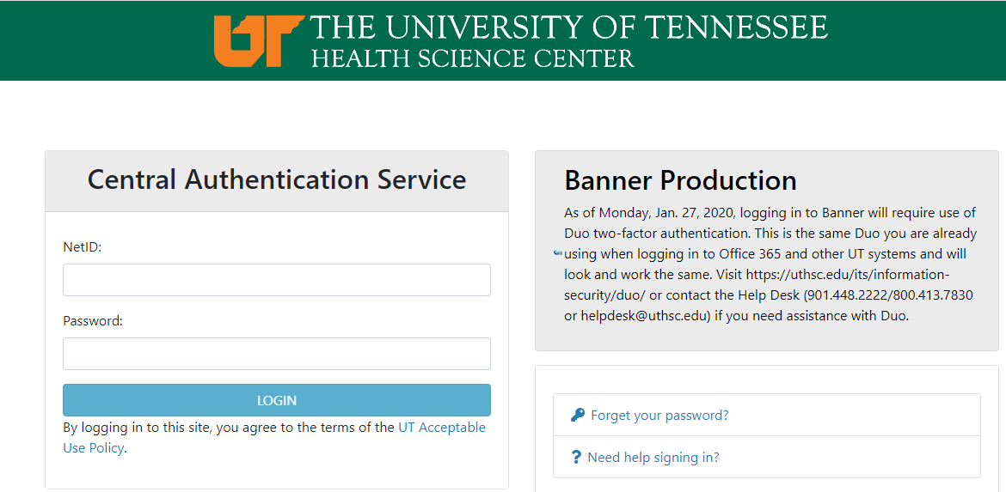
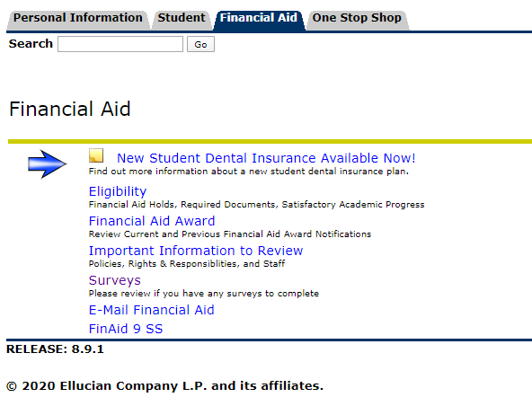
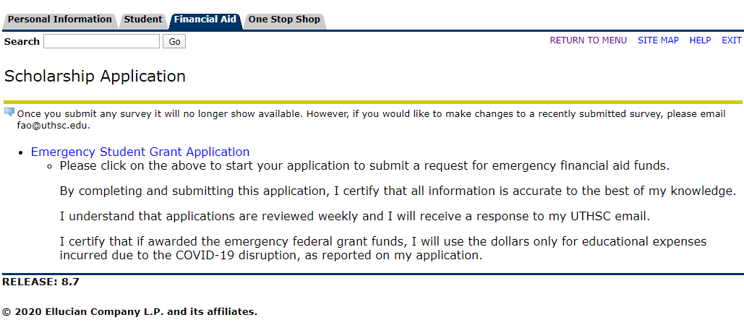
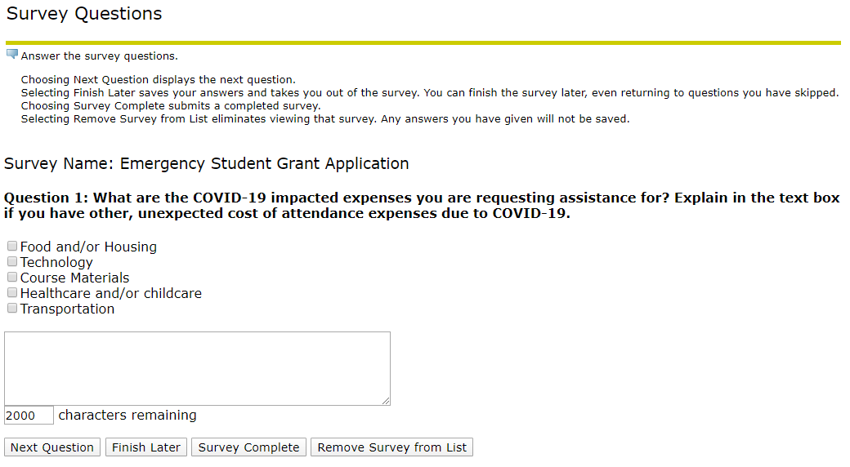
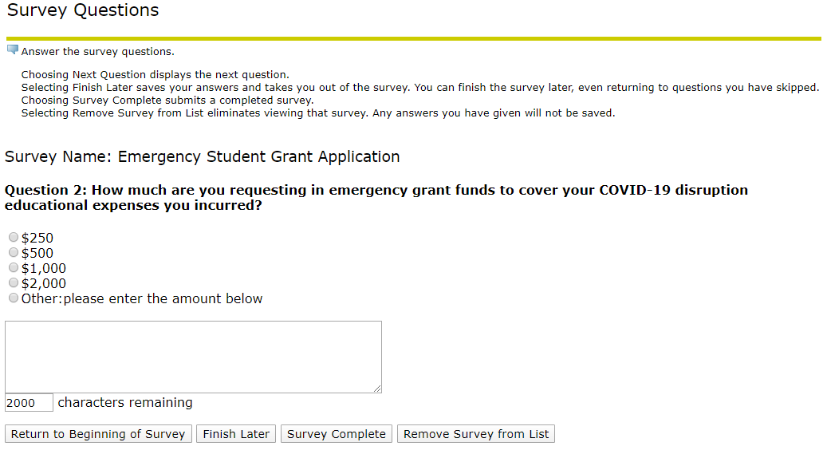

Original posting May 20, 2020
Information updated July 1, 2020.
Information updated July 6, 2020.
Information updated August 14, 2020
First quarterly report for period through September 30, 2020 published October 6, 2020

