Career Resources for Transitioning from Academic to Private Sector Health Sciences Jobs
Articles; Transitioning from Academic to Industry
- From Academia to Corporate: How to Make a Major Career Transition. Debra Wheatman.
- How to Survive Outside of Academia: Interview with a Data Scientist and a Science Consulting Coach. Sho. May 16, 2017.
- Leaving Academia. Elisabeth Pain. Mar. 7, 2016.
- Like Science? STEM Jobs at Nonprofits are More Common than You May Think, Part 1. Samantha Fredrickson. June 5, 2017.
- Top 10 Industry Jobs For PhDs (or, Why You Don't Have To Do A Postdoc). Arunodoy Sur, Ph.D.
- Transcending the Transition from Academia to Industry. Clifford S. Mintz. May. 14, 2004.

Career Resources; Resumes and Cover Letters, Interviewing, and Career Skills
Resumes and Cover Letters
- Converting Your CV to a Resume.
- How to Craft a Resume When You Have No Experience Outside Of Academia. David Lumb. September 2, 2015.
- How to Find a Job in Biotech and Resume/CV Tips.
- Resumes & Cover Letters for PhD Students.
  - Variety of resources based on different positions being applied for
- Resumes for industry scientist job applications.
- Sample CVs for Graduate Students and Postdocs.
  - Samples of both academic and non-academic CVs.
- Sample Resume for an Experienced Research Scientist
- The Versatile PhD.
  - Non-academic career suggestions for STEM majors. Sample resumes included.
- What Biotech Recruiters Look for in a Good CV. Ellen Clark. May 22, 2012.

Interviewing
- Interviewing for Jobs outside Academia.
- Preparing for the Non-Academic Interview. Christine Kelly. May 29, 2009.

Career Skills
- Explore the skills that can open career doors after your doctoral training. Maggie Kuo, Jia You. Nov. 27, 2017.
- PhD Myth Busters: Making the Transition from Academia to Industry. Ryan Raver. March 1, 2015.
  - Resources on crafting a non-academic resume, networking, and job skills outside of academia
- The Versatile PhD.
  - Non-academic career suggestions for STEM majors. Sample resumes included.
- What Recruiters Look At During the 6 Seconds They Spend On Your Resume. Vivian Giang. April 9, 2012.

Searching for Non-Academic Employment
** The following companies are not endorsed by the college or university, but serve as an example of employment resources for a specific discipline.
Non-Profits (Foundations, grant administration, healthcare administration, scientific societies, etc.)
Salaries will fluctuate with a median salary of $50K-90K depending on the organization.
- American Chemistry Society
- Cystic Fibrosis Foundation
- Fred Hutchinson Cancer Research Center
- Guide Star (non-profit organizations and charities)
- Healthcare Source Job Board
- Idealist (search “science non-profits”)
- National Science Foundation
- The Scripps Research Institute
- US Department of Veteran’s Affairs; Careers
- US Agency for International Development
Fellowships
- American Association for the Advancement of Science (comprehensive list of fellowships, and other science career options)
Law (Patent law/agents, lobbyists, etc.)
Pay will vary depending on the size of the law firm and geographical location. Salaries for specialists/scientific advisors ranges $85K-95K, and $100K-115K for patent agents who have passed the patent bar. Note: Most law student advisor sites do not recommend LLMs.
- United States Patent and Trademark Office
- Patent practitioners can sit for certification without a J.D
Policy (Government, think tanks, analysts, private research centers, consulting, etc.)
Median salaries range $50K-$90K for government post-doctoral fellowships.
- Bill and Melinda Gates Foundation
- Bio Careers
- Brookings Institution
- Cardno Chemrisk (research, consulting, medical, non-profit, public health, science policy and writing, etc.)
- Department of Defense
- The Heritage Foundation
Journalism (Scientific writing, science publishing, medical communication, etc.)
Median salaries range $50-70K, and employers usually request 1–3 years of experience.
- American Medical Writers Association
- National Association of Science Writers
Consulting/Technology (Bio-tech startups, etc.)
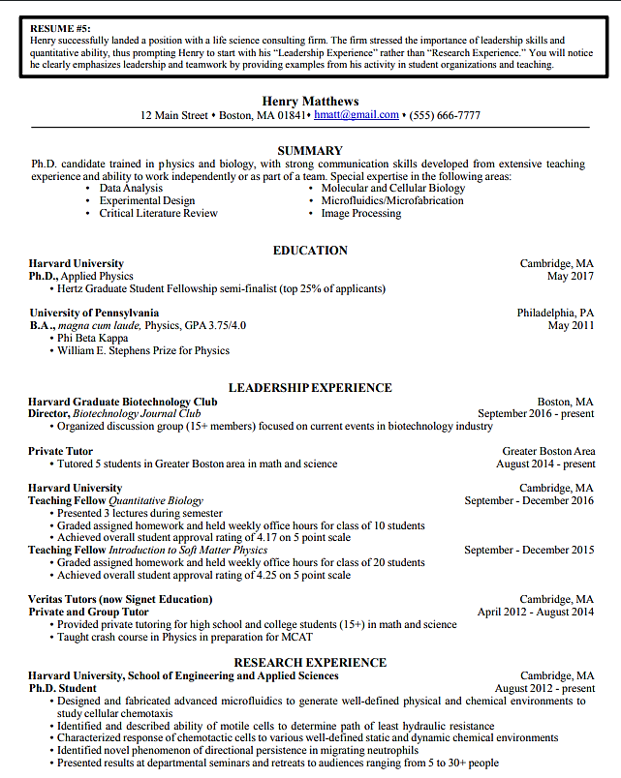
Salaries and bonuses can largely be dependent on the employer. Salaries range from $60-90K for a smaller firm, and $70-120K for a larger firm.
- American Chemistry Society
- AngelList
- BioSpace
- LinkedIn
- San Diego Biotechnology Network
- Science Careers
- Society for Neuroscience
Defense
The median salary for civilian positions ranges $60K–100K.
- Department of Defense
- USA Jobs
Job Search Engines
- Indeed
- LinkedIn
- Monster
- SimplyHired
- Zip Recruiter

Sample resume from Resumes & Cover Letters for PhD Students.
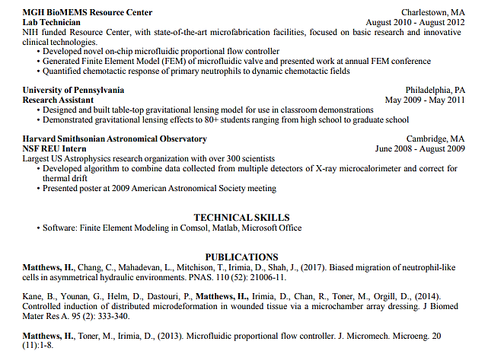
Salary information adapted from PhD Career Guide.

