Investigator/Coordinator Guide
2022
Revised: March 7, 2022
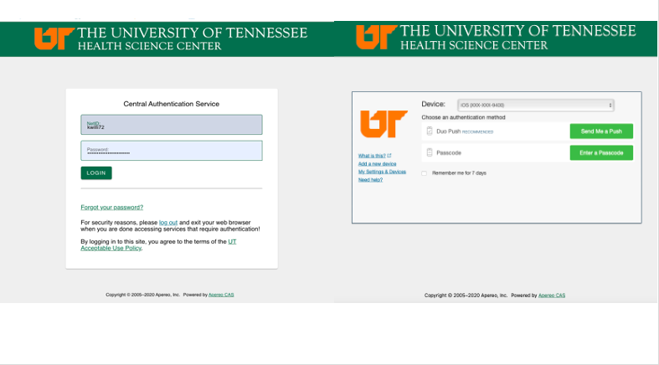
Table of Contents
Getting Started 3
Navigational Tips 4
Adding a New Application (Form 1) 7
Routing Form 17
Routing for Signatures 19
Workflow Tracking 23
Signoff 27

Getting Started

- If you are new to using the UTHSC IRB, please go to our website at http://www.uthsc.edu/research/research_compliance/IRB/index.php (bookmark this page!) and review the Getting Started page (https://uthsc.edu/research/compliance/irb/researchers/getting-started.php).
It contains the basic information you need to know when preparing to submit a research application to the IRB.

- Open your web browser. Make sure you are using a version of an Internet browser that is supported by iMedRIS.

- Chrome
- Edge
- Firefox
- Safari

- Type in the iMedRIS home page web address: https://imedris.uthsc.edu (bookmark this page) and you will be directed to the DUO login screen. Please note, prior to accessing iMedRIS, you will need to install the “DUO Mobile App” https://www.uthsc.edu/its/cybersecurity/duo/. The University requires this two-factor authentication to protect against cyber-attacks.

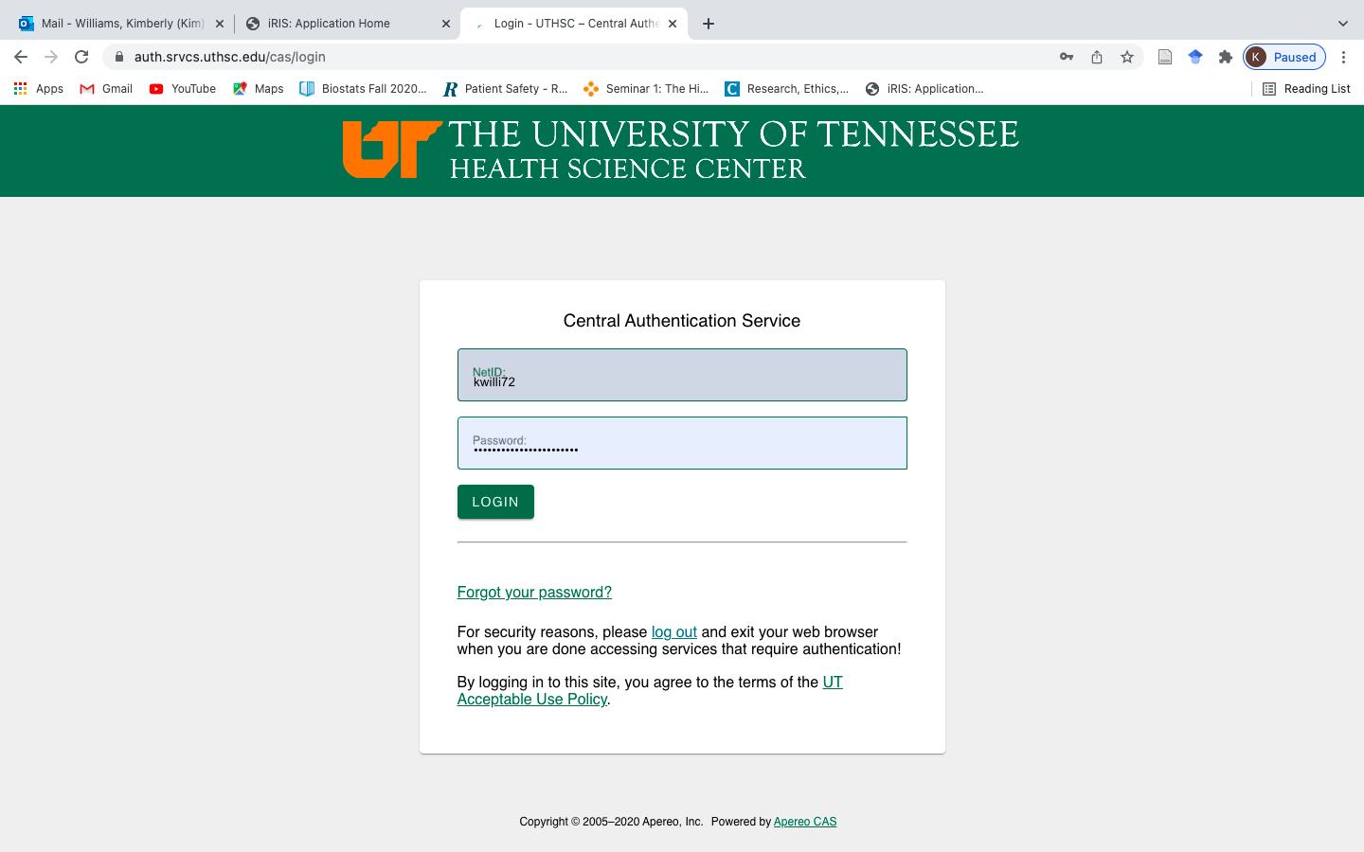

- Log in using your UT Net ID and Password. If you need to obtain a UT Net ID, go the UTSHC IRB website at http://www.uthsc.edu/research/research_compliance/IRB/started.php and follow the instructions under Step 1: Get a UT Net ID. If you are having trouble with your password, you will need to contact the Help Desk at (901) 448-2222.

- Next Log in via DUO either though the app or token provided by the office of Information Technology.

Navigational Tips

- For security reasons, iMedRIS will log you out after 90 minutes of inactivity. There is a 25-minute warning that will ask if you would like to continue working. If you are not available to click the button, you will lose any unsaved information when the system logs out. Before leaving the computer, make sure you have clicked on the top right of the screen before stepping away from your work.

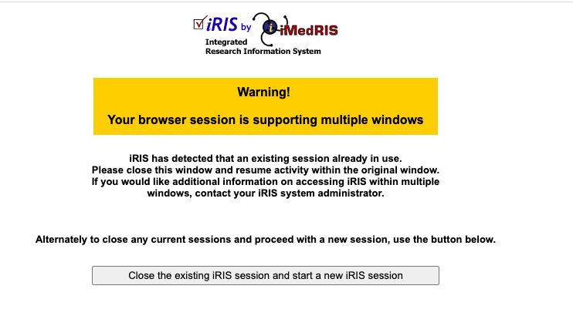

- Once you have logged into iMedRIS, the Welcome to Study Tutorial List will appear. You have the option to view the tutorial (recommended ) to learn what each action button does. Optionally you can unselect Display Study tutorial at login . Please note that colors in the images in this guide may be of a different color than the study application; however, the steps are words are consistent.

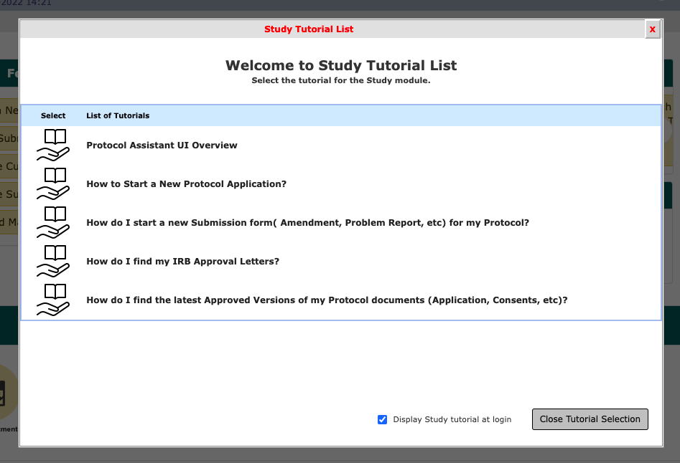

- After you go through the tutorial or unselect the tutorial the iMedRIS home page will appear.
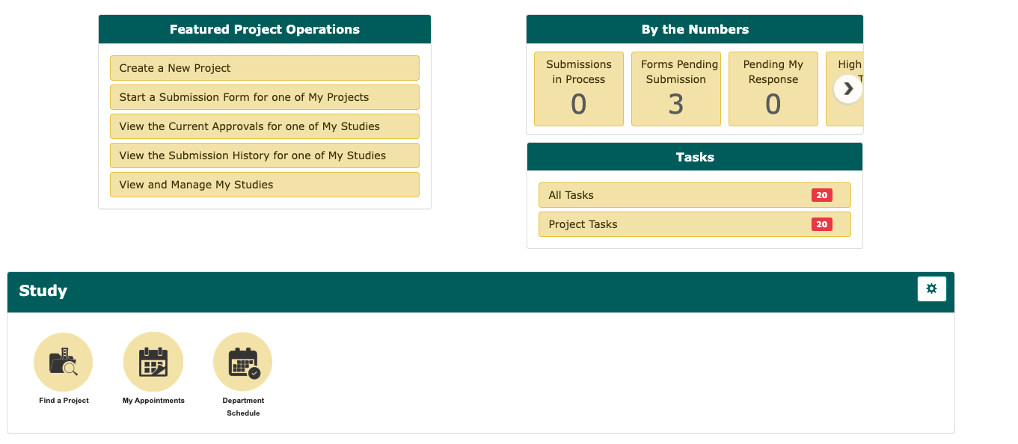

- The logo in the top left corner will return you to the iMedRIS home page.

- The 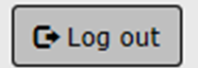 button on the top right of the screen allows you to exit the iMedRIS system.

- The button on the top right of the screen provides links to the IRB member and clinical researcher iMedRIS Guides & Tips and link to the IRB policies.

- The 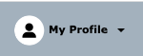 tab on the right contains your account information including your CITI training, iMedRIS announcements, and help files.

- The at the top of the page contains the button to Create a New Project via the IRB new application form (Form
- In addition, under this panel you may access all of your studies that have been registered or created in iMedRIS under View and Manage My Studies.

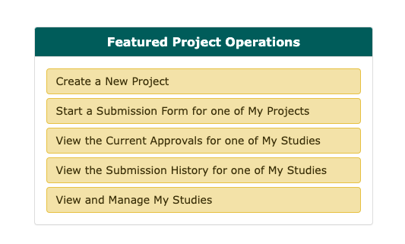

- Please note that if you are an IRB Board member and have access to the UTHSC IRB Assistant tab, you can switch to the Study tab by going to My Workspaces at the top left of the screen, hover over/highlight Study, then click on Project Workspace.

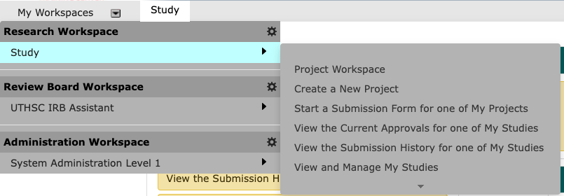

Adding a New Application (UTHSC IRB Form 1: Study/Project Application)

- Under, click .

- This will take you to a page where you will select UTHSC IRB Memphis Form 1: Study/Project Application. Then click on start selected application:

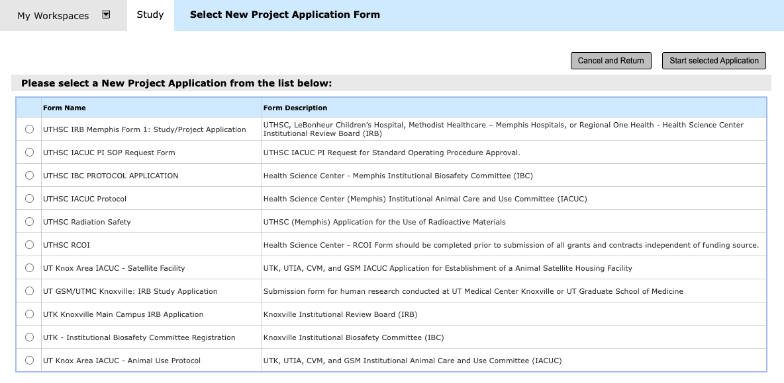

- The first section of the UTHSC IRB Memphis Form 1: Study/Project Application (new application) will show as below:

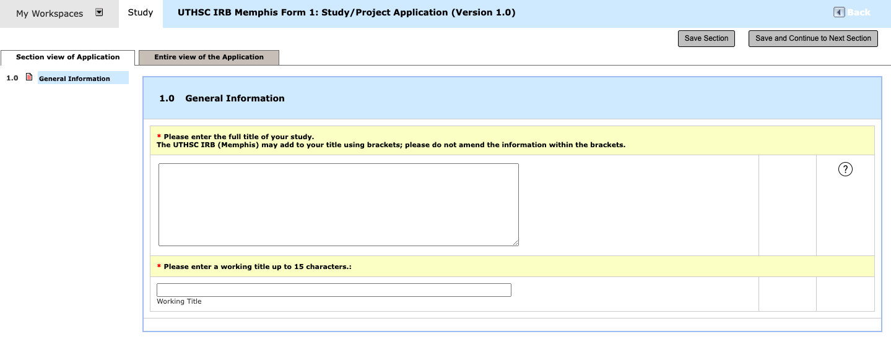
- After you have answered all of the questions in a section, click
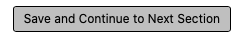 to get the next set of questions.

- The button on the top right corner of the screen will take you to the previous page. DO NOT USE the back button on your Internet browser when you are in iMedRIS! To navigate back through the application, click on the Sections in the column on the left side of the screen. The “Back” button will not take you back one page (to the previous section) when you are working on an application.

- When adding or deleting departments to the application in section 2.0, click the appropriate button: OR

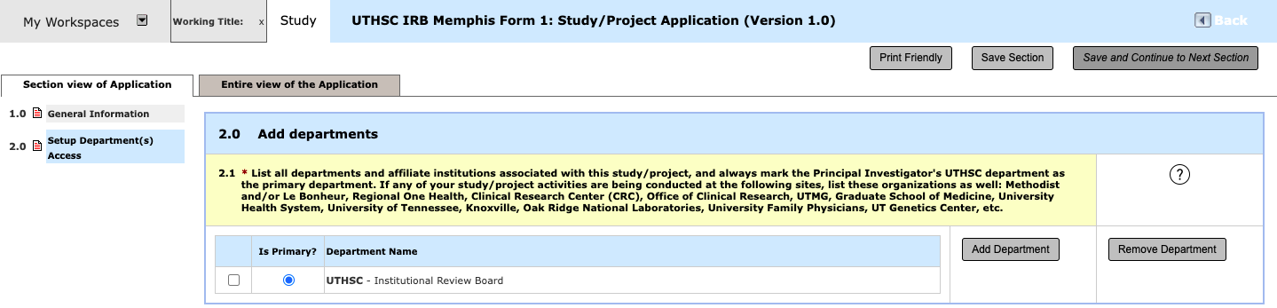

- When adding personnel to the application in section 3.0, click 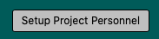.

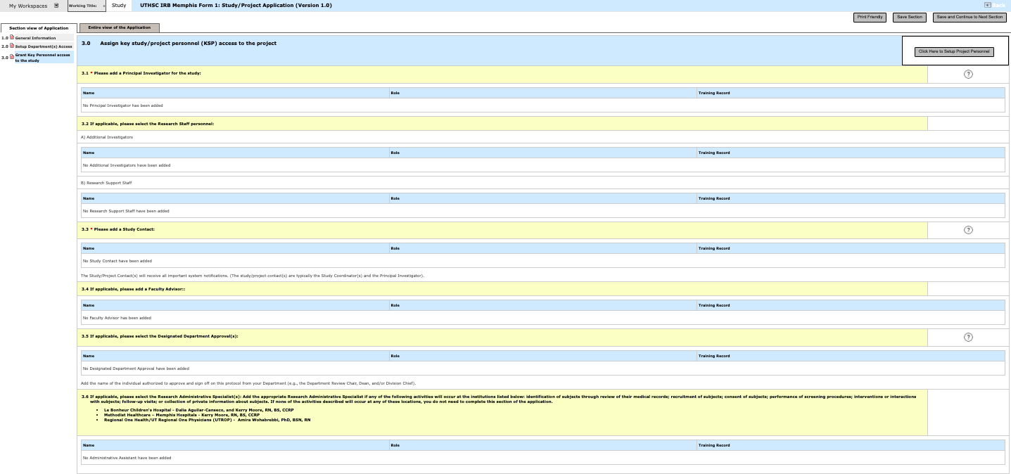

- Click Find User/Search Directory after typing in the last name for the person.

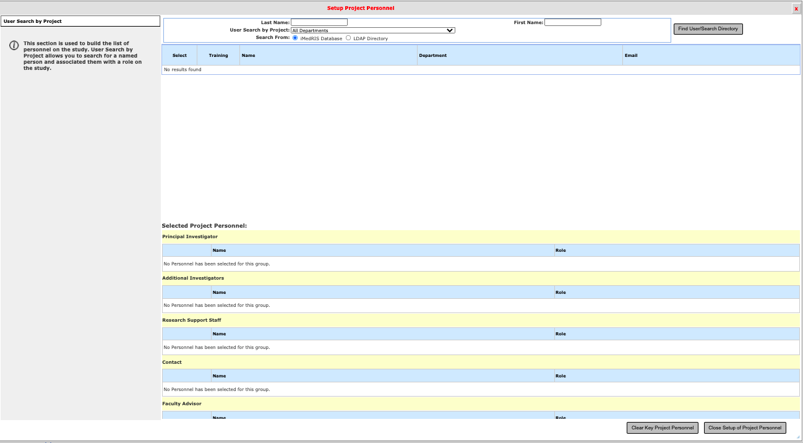

- When you have found the person you want to add, click the person icon beside the diploma hat icon.

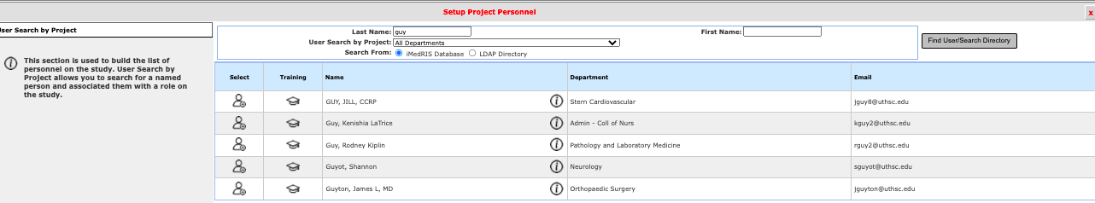

- On the next screen Select the role for the personnel selected. Select the role of the personnel and select if they will be a study contact or not followed by clicking Save.

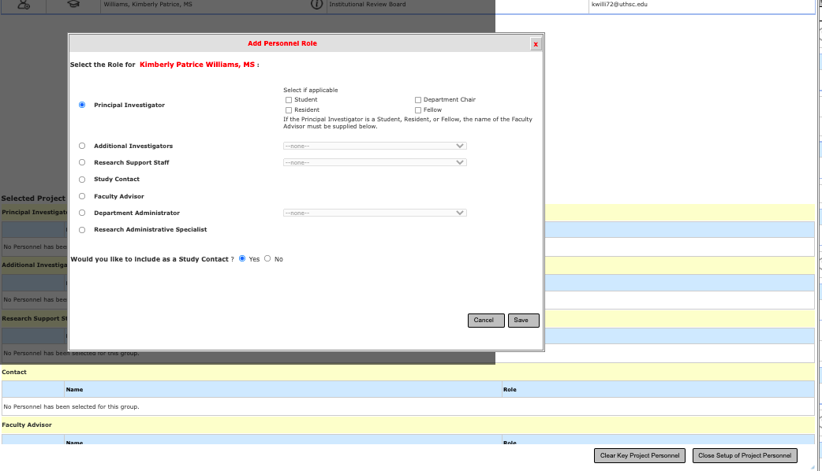

- After you have entered all personnel click Close Setup for Project Personnel.
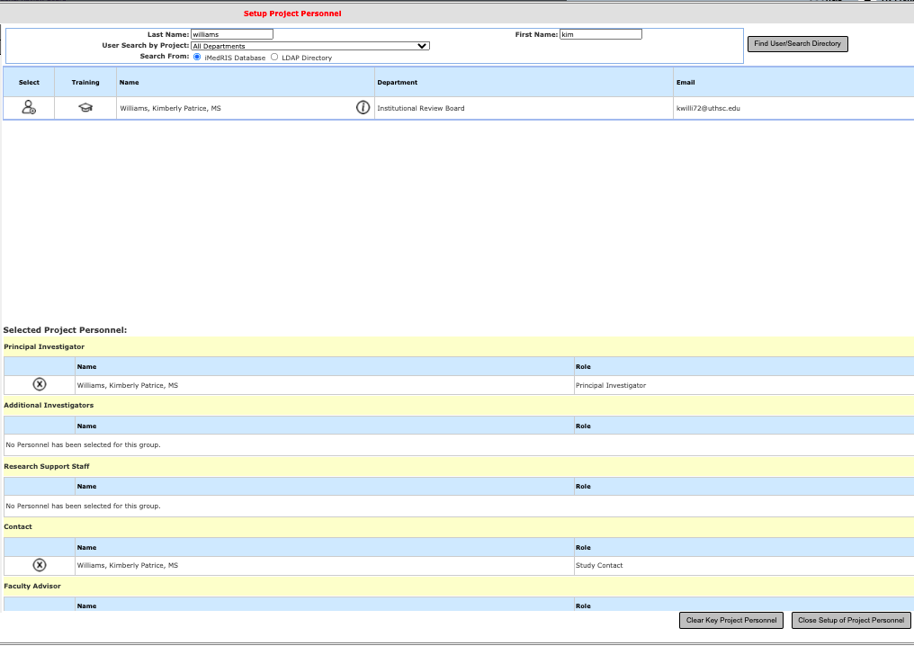

- The screen should return to your application, and you see the name in section 3.0. Click Save and Continue to Next Section.

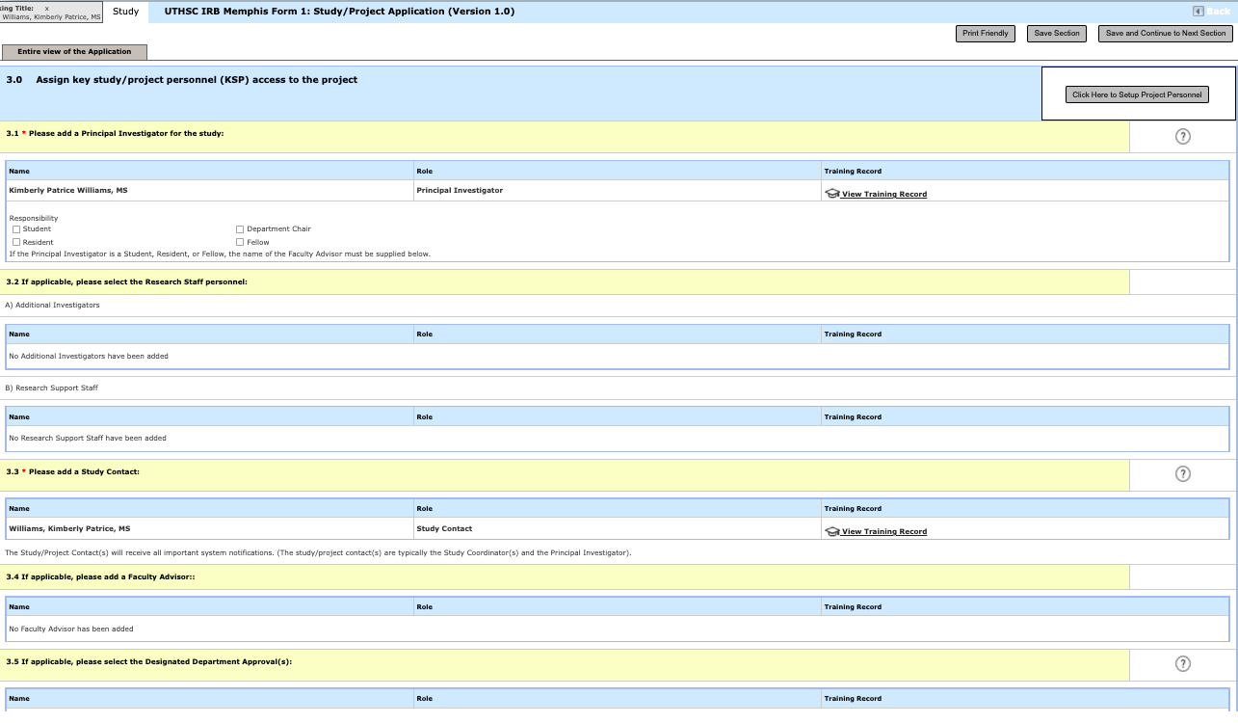

- In section 415, you should select Click here to add another entry to enter those listed in section 3.0, except for the department chair, and/or hospital chief, if applicable, and Research Administrative Specialist. Click Save and Continue to Next Section after all entries are complete.

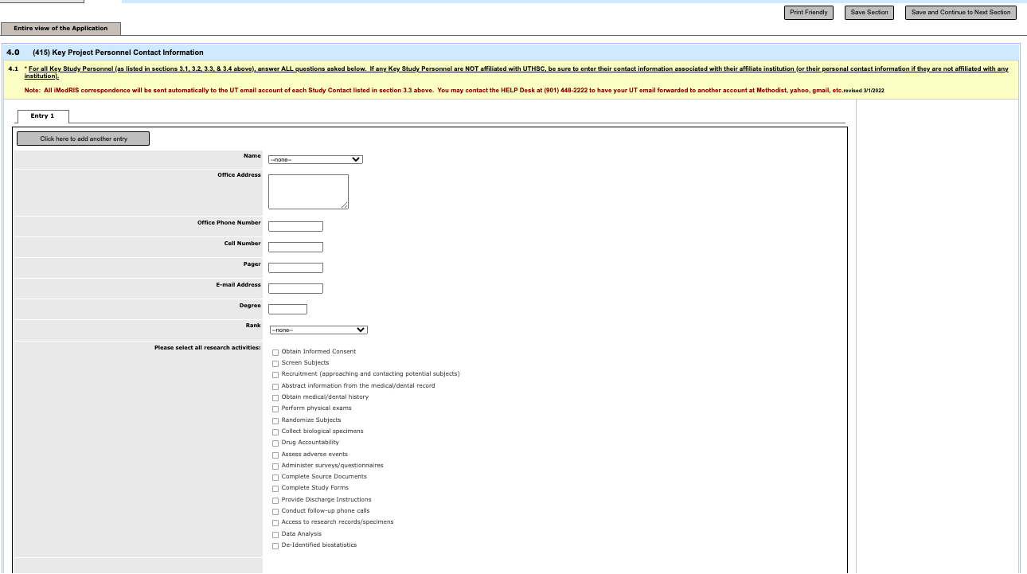

- Carefully read all of the options in section (418) to ensure you are choosing the correct application for your project.

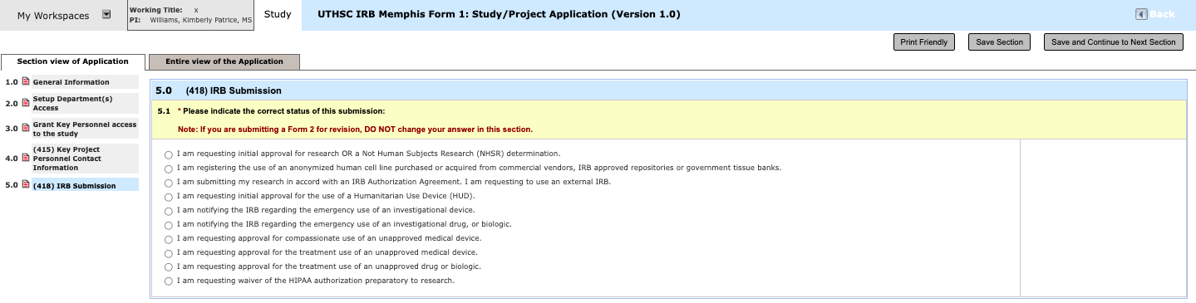

- In section (420) answer all questions related to other institutional resources that may be involved in your study. These include the Electronic Data Warehouse, the Radiation Safety Committee, the Institutional Biosafety Committee, and the Institutional Animal Care and Use Committee.

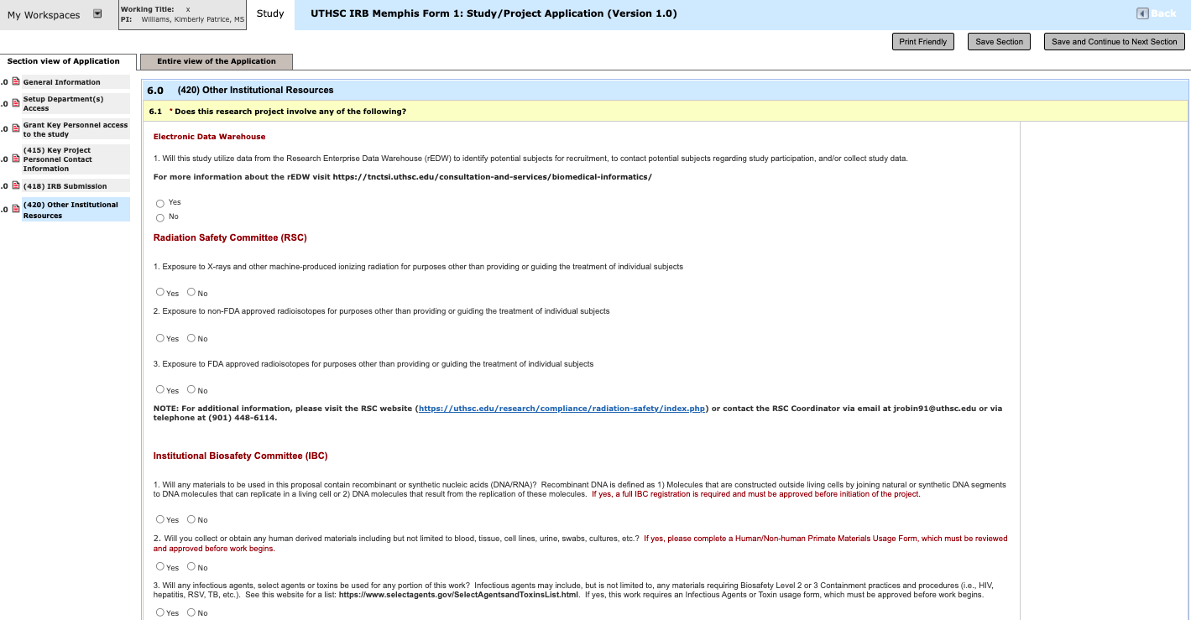

- In Section (468) Select whether there is a funding source for the study.

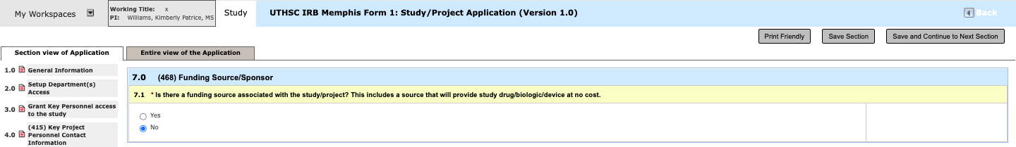
- In section (485), if you are uncertain as to whether your study will require full board, expedited, or exempt review, please call the IRB at 448-4824. Also in this section indicate whether a device or biologic is being used in your study.

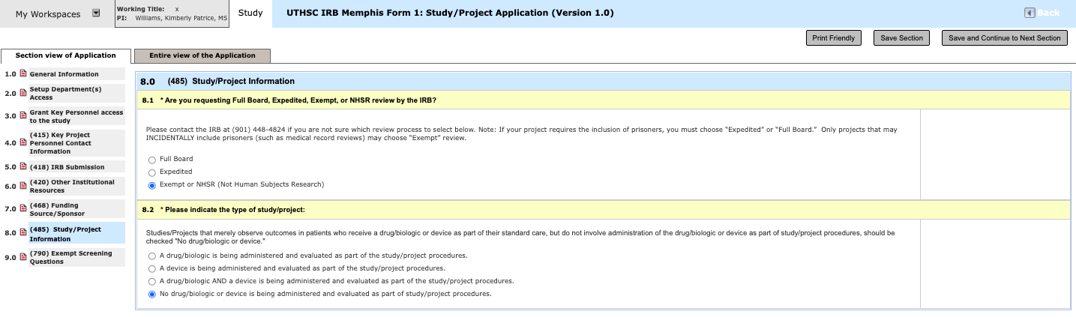

- If you have selected “exempt” in section (485), you will receive the exempt branching question, section (790). To launch the exempt subform, click on the gray bar “Click here to start this form”.

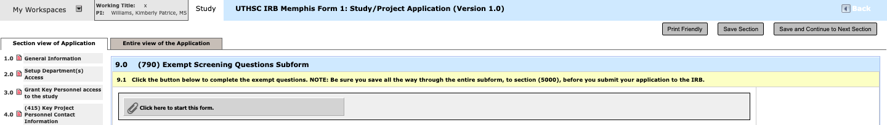

- Once inside the exempt branching subform, the 1st question will be the exempt screening questions. You should read all of the options, then check the option that best describes your project. If your project does not EXACTLY fit one of the descriptions below, go back to section (485) and check “expedited”. Once you have made your selection, answer any other questions that populate, and then click Save and Continue to the Next Section.

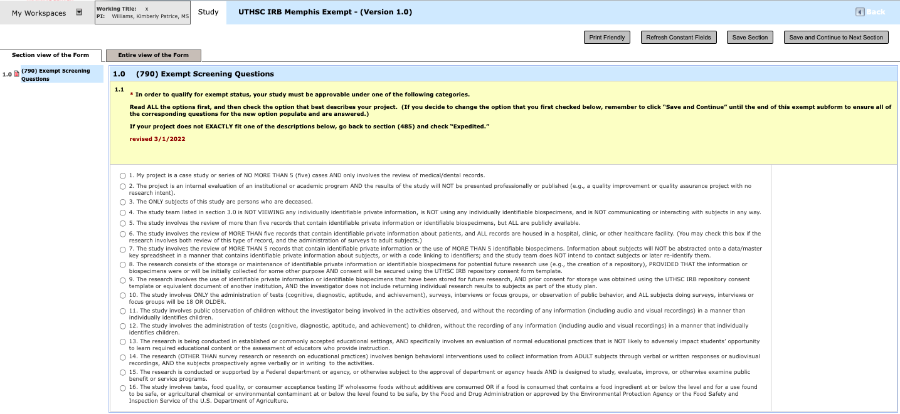

- You should click Save and Continue to Next Section until you reach section (5000) References.

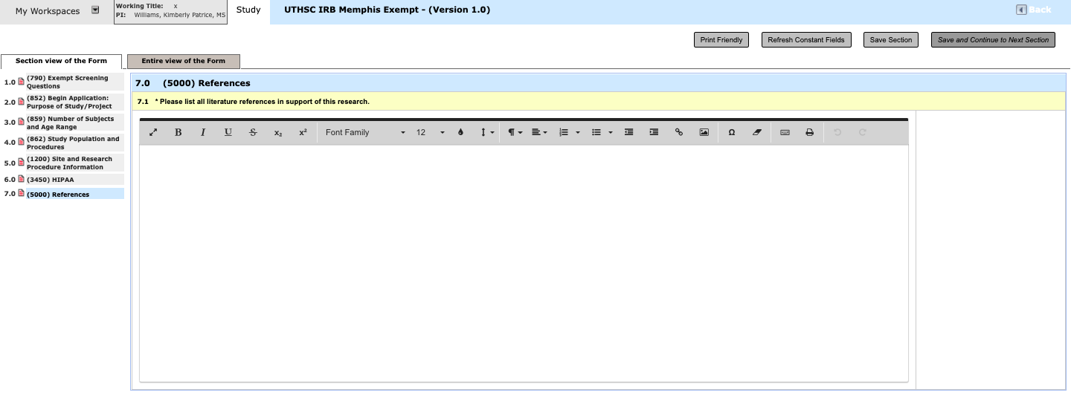
When you click Save and Continue to Next Section on this page, You will receive the following message: . Click on . This will take you back to the application. You should see all of the questions you’ve answered all the way through section (5000). Click Save and Continue to Next Section.

- You will them be routed back to your submission form Click Save and Continue to Next Section.

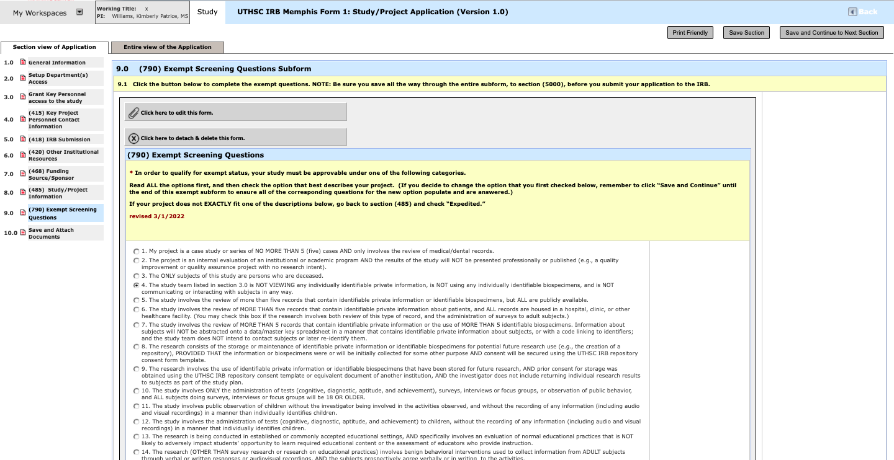

- You are not finished with your application until you see the section that says Save and Attach Documents.

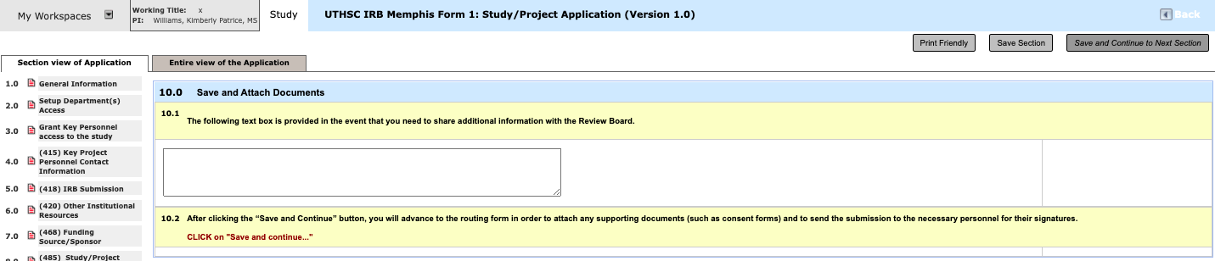

- Once you save the last section, you will receive the following message:

- The system will automatically take you to the Routing Form where your application will be attached. Click Save and Continue to Next Section.

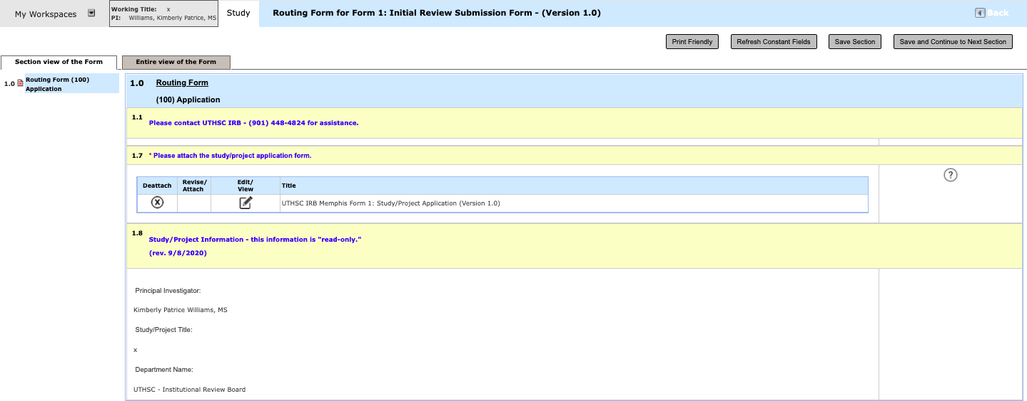

Routing Form

The Routing Form is the package you send to the IRB that contains your application, consent form (if applicable), and additional study/project documents such as surveys, sponsor protocols, investigator’s brochures, package inserts, etc.

- You save through the routing form just as you did the application and the sections populate on the left side of the screen.
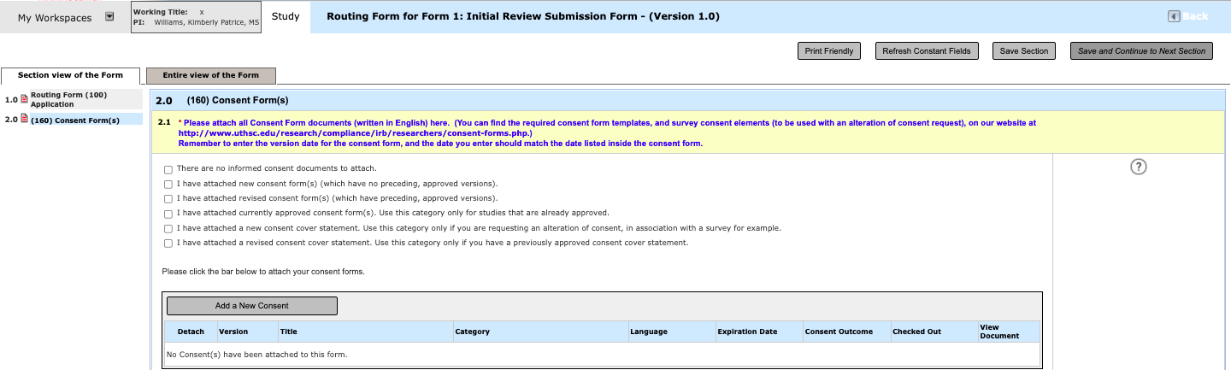
When it prompts you to upload the protocol or consent form, click the

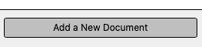

or the button.

- Each document you upload will need a general title, such as Main Consent Form, Repository Consent Form, Questionnaire, Screening Script, etc.
- Note that the Version Number will populate automatically; you do not need to change this.
- Next, you should make the Version Date the exact same date that is shown inside your document!
- Lastly, if you are uploading a document that is not a consent form, you also must choose the most appropriate category, such as Master Protocol, Investigator’s Brochure, Recruitment Materials, etc.

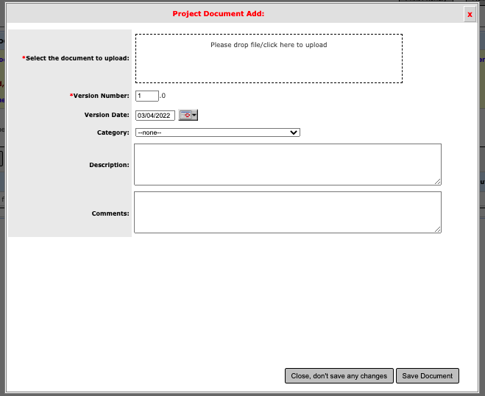
- After you have attached the consent form or additional study/project documents, ensure that it shows up on the consent form or additional study/project documents page of the routing form. Click Save and Continue to Next Section
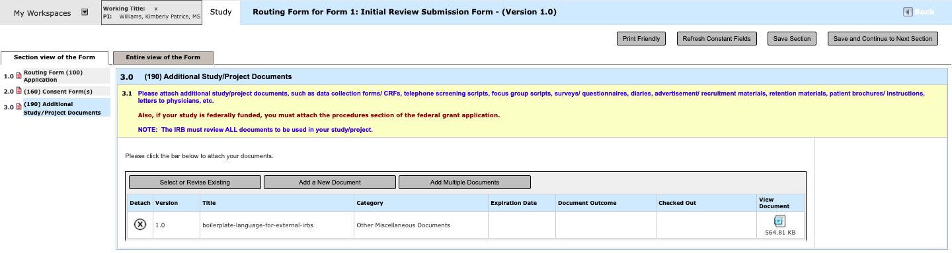

- After you save, you will get the screen below. You are not finished with your application until you see the section that says Complete Form or Form Completed. and you can either click “Exit Form” if you are not ready to route your submission for signatures, or you can click “Signoff and Submit” if you are ready to route your submission for signatures.

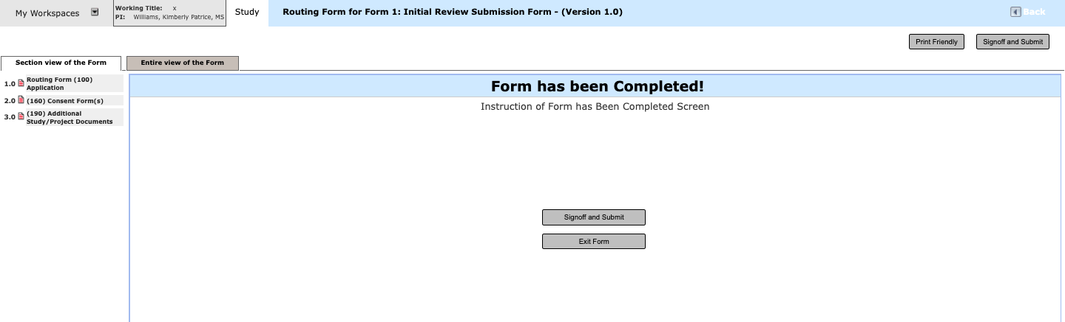

Routing for Signatures

- After clicking Signoff and Submit for any type of submission, you will be asked if the submission requires additional routing for approval.
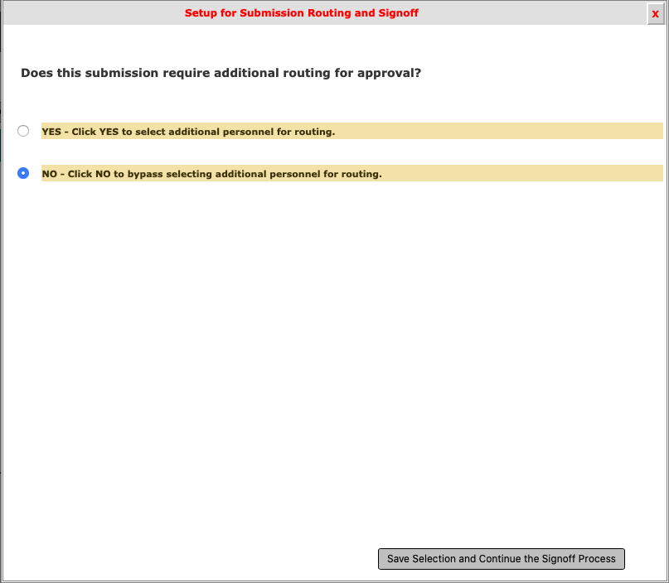

- Change the answer to Yes if you have anyone in addition to the principal investigator who must sign off on the submission. Please see the chart below for required signatures.
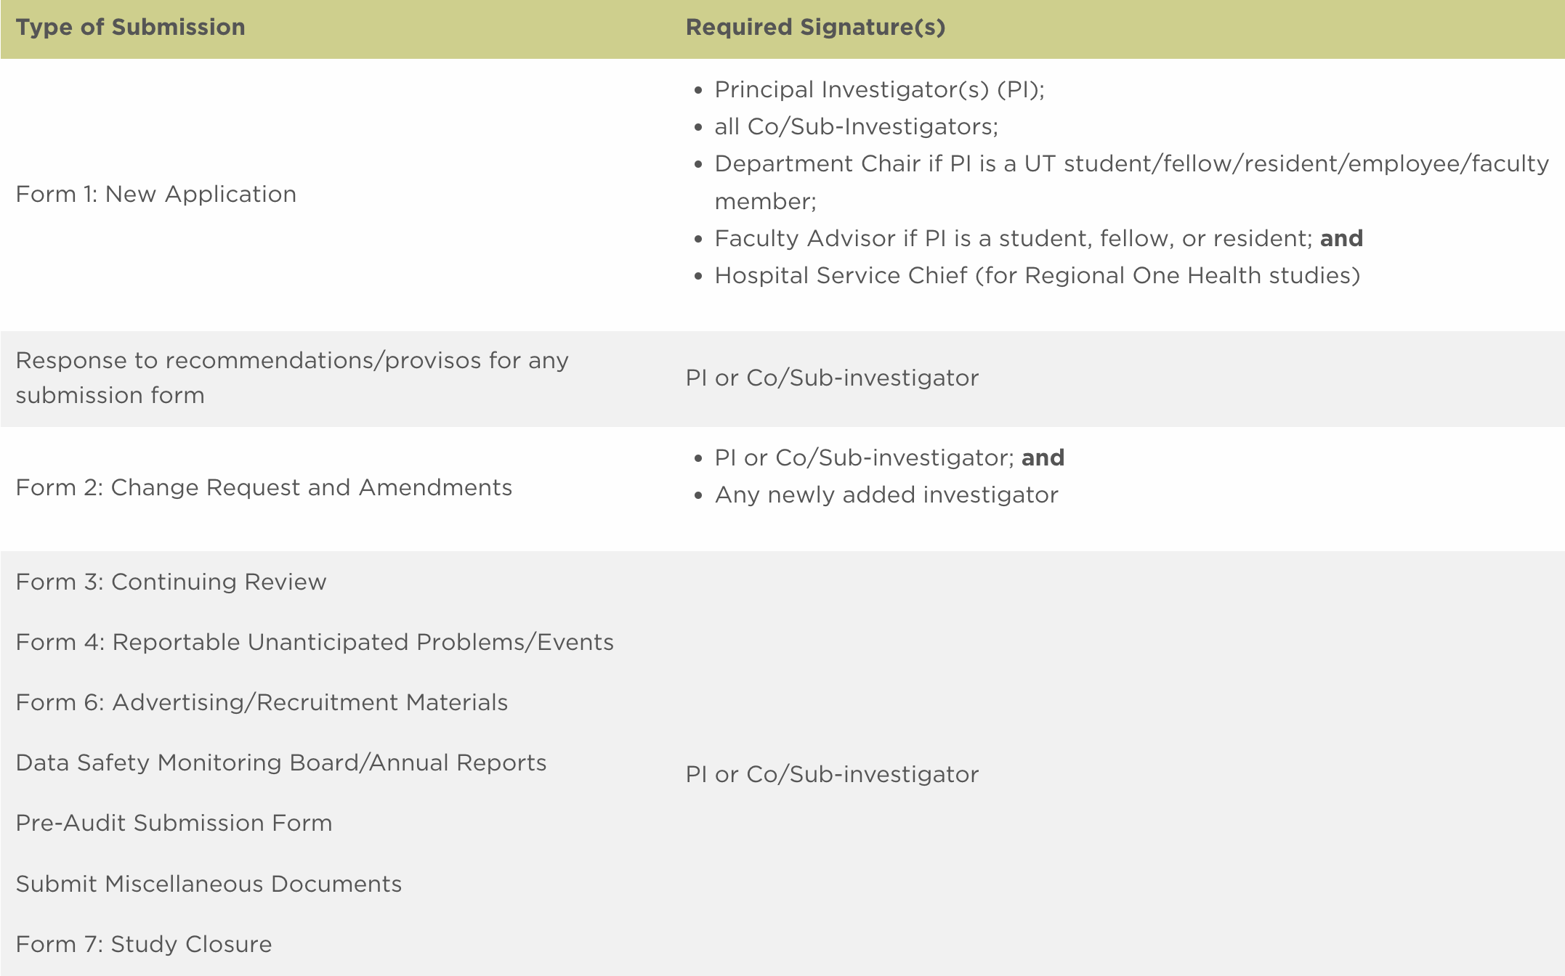

- If you need to send to anyone besides the principal investigator to sign off, check Yes and then click Save Selection and Continue the Signoff Process button in the bottom right corner.

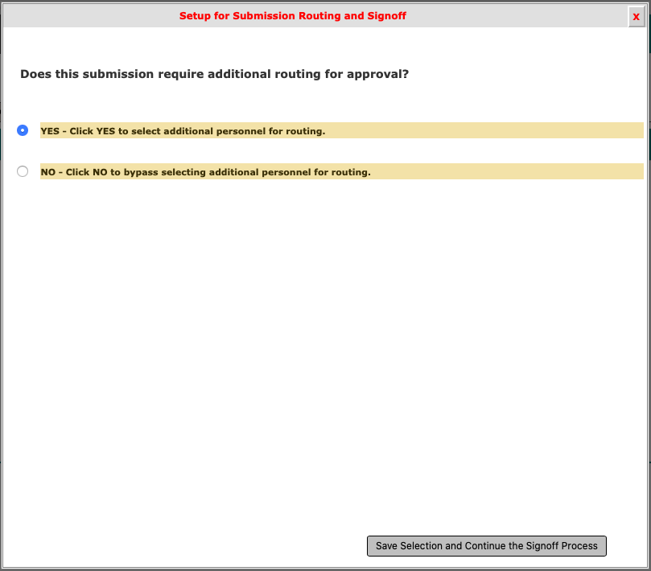
- Once you click Save Selection and Continue the Signoff Process button in the bottom right corner, all investigators, department chairs, & hospital chiefs will appear. Make sure you check the box beside the people who need to sign off so that they are included in the routing for signatures. If there is someone that you entered in Section 3.0 that does not appear on the sign-off list, you may click the Add Additional Personnel to the Routing List button. Note: if some investigator names do not appear, you did not include them in section 3.0 of your application, so you must go back and revise your study application.

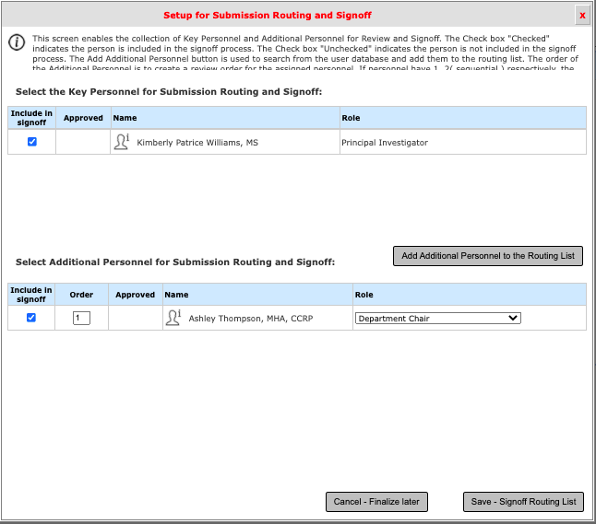

- Once you click Save-Signoff Routing List, you will be asked to verify that the list above represents the finalize Personnel for review and sign-off. If the list is correct, click Yes and then click Save-Start Signoff Routing. If not, click No and select Cancel-Finalize Later or Go Back to Make Changes.

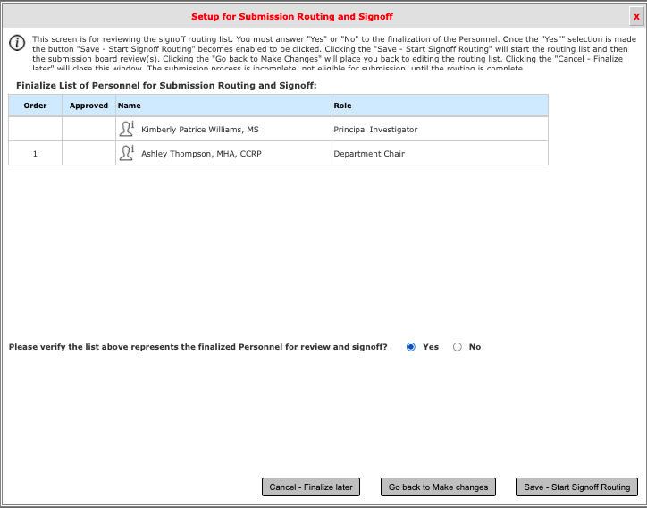

- You will then see the screen below. You may click OK or wait until the 10-second countdown ends, which will then take you to the PI Responsibilities screen.

- Review the PI Responsibilities and select Approve and then Save-Signoff.

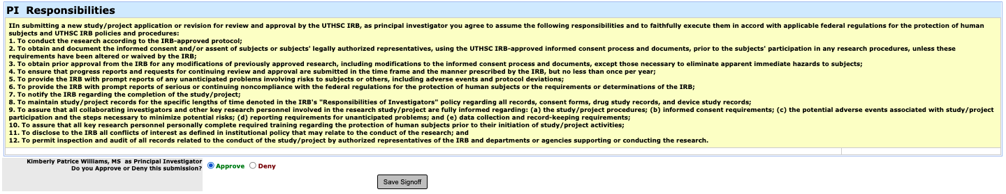

Workflow Tracking

- Once you save after saying Yes, you will be routed back to the Study Workspace. This page allows you to see your submissions. To track your submission, scroll to the section All Projects. Click on the arrow icon to view the project dashboard.

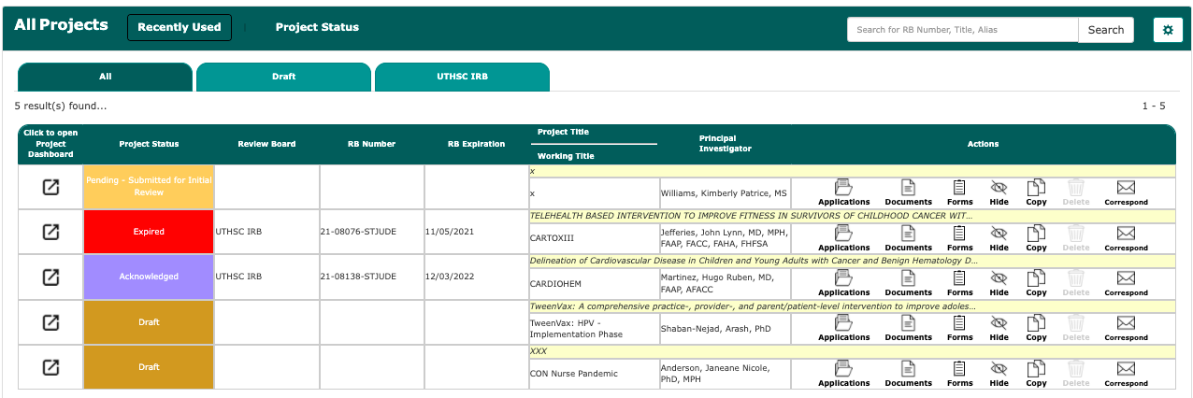

- You can click on magnifying glass icon in the green Waiting for Signoffs box to get to the Workflow Tracking page to see where your submission is in the electronic process, who has still not signed off, and whether the IRB has received your submission.

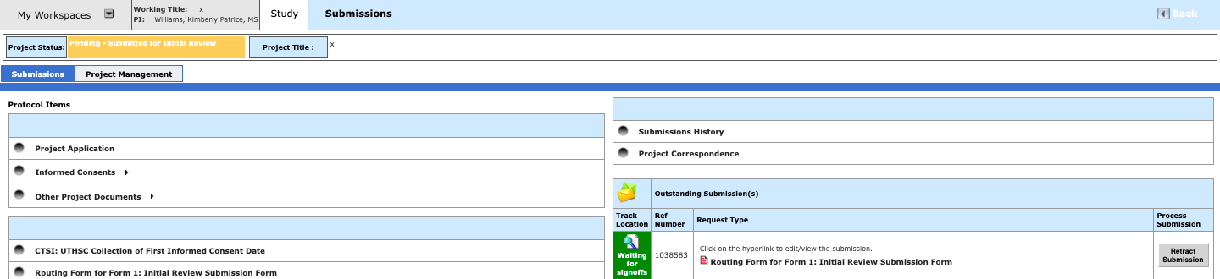

- Click the orange button entitled Pre-Submission followed by the “+” next to the words Pre-Submission on the left.
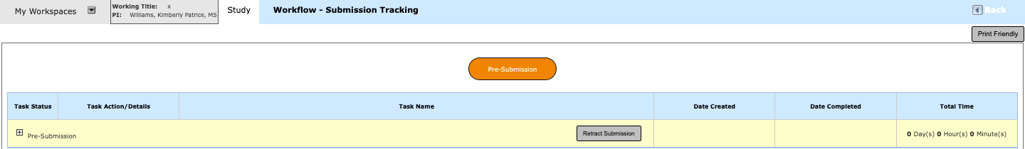

- Below, the Principal Investigator, Kim, has signed, indicated by the View Signoff box in the Task Actions/Details column and the words Completed to the left of this box. Sign-off is still pending for Mary Susana Caver, Faculty Advisor, indicated by the Pending Signoff box in the Task Actions/Details column. Note that the department chair is not listed on this page. In addition, the IRB will NOT receive the submission until all persons in the routing assignment list, including the department chair and/or hospital chief have signed. If you want to change your routing assignment list, you can click on the Modify Signoff Routing List icon in the Task Action/Details column and re-save your list

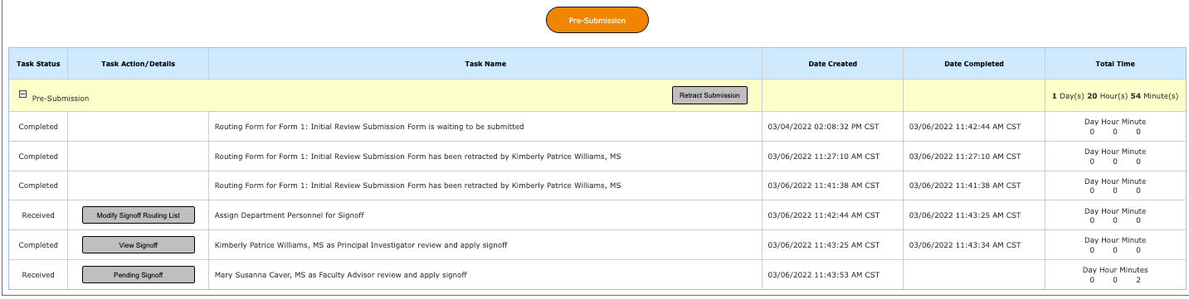
.

- If you want to change your routing assignment list, you can click on the Modify Signoff Routing List icon in the Task Action/Details column and re-save your list

- After the submission has been routed to the IRB, the project status will appear on the Study Workspace page. You can view what step your submission is in the pre-review process by clicking the Steps icon in the Actions column.

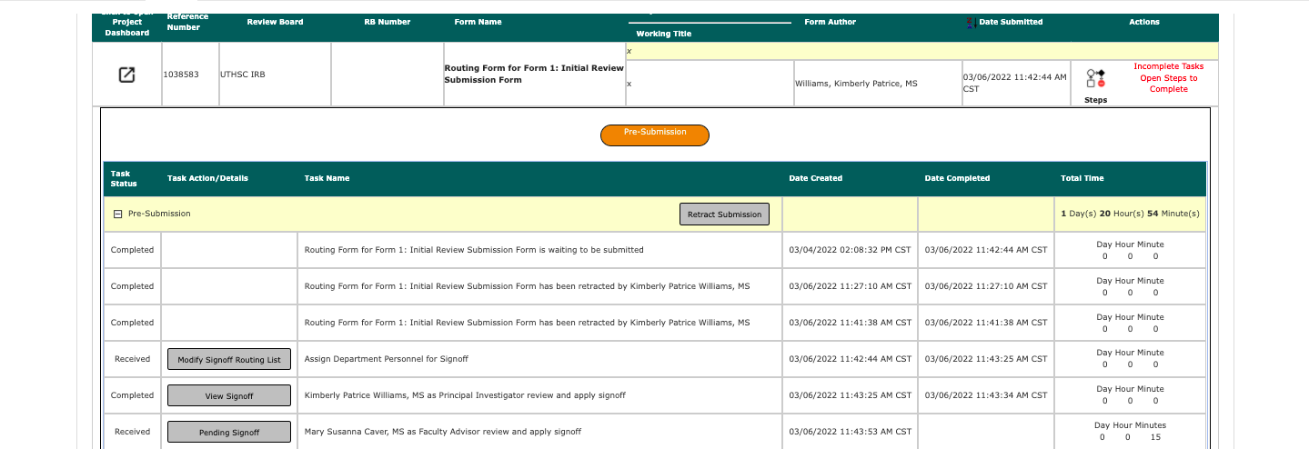

- After the IRB has received your submission, the Outstanding Submission information will no longer be on your study’s home page.

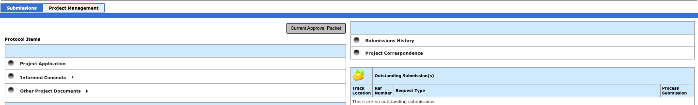

- You must go to your Submission History to get to the Workflow Tracking page.
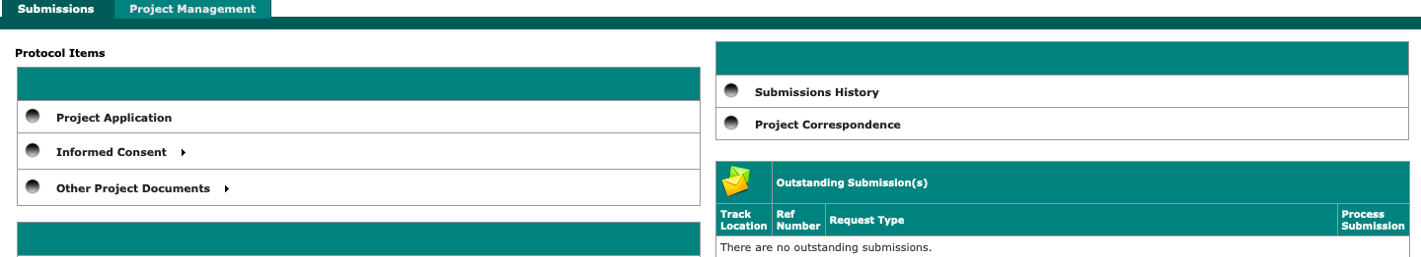

- Then, click on the Track Location button.

- You can then see the status of your submission again. You can also see who was assigned as your analyst in the IRB office by clicking the highlighted button that describes where your submission is in the review process. If you have questions about your project, call and ask for this person as she will be the most familiar with your project.

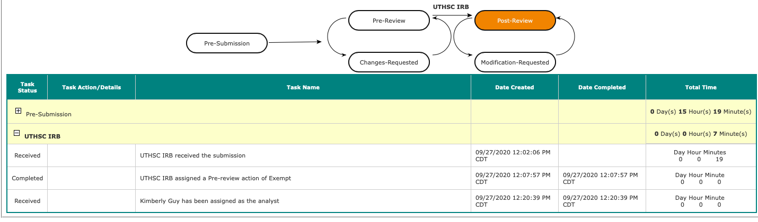

- If you log out of iMedRIS and want to find your project again, log into iMedRIS. On your home screen, under My Workspaces tab on the top left of the screen, hover over/highlight Study and then click on View and Manage My Studies. Note that if you are already in the Study tab, you can also click View and Manage My Studies under the Featured Project Operations section at the top of the page.
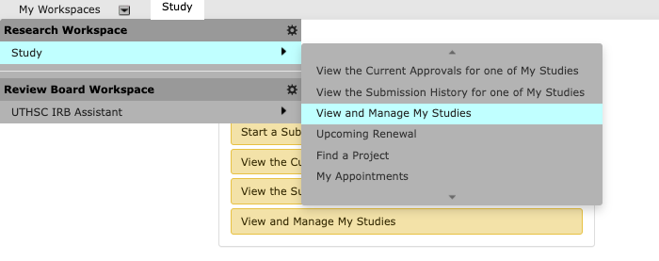

OR

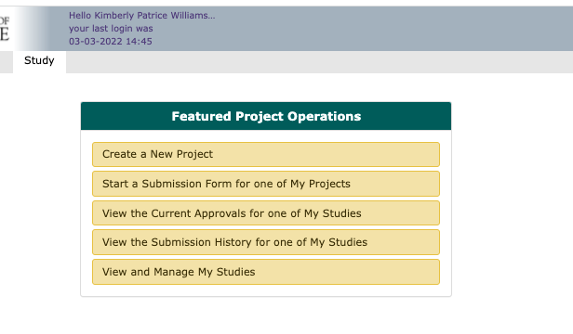
- You will see your list of studies/projects. Click to Open the study you wish to view.

- This will take you to the Submissions screen. Click Submission History and then Track Location as described above.

Signoff

- If you are the principal investigator or a co-/sub-investigator submitting to the IRB, you will be asked to sign off on the submission after you finish the routing assignment list.

- Click “Approve” if all of the submission components accurately represent your project, and click Save Signoff.

- If you did not submit your project’s form to the IRB, but you need to sign off, you will have a Submission Routing Signoff notice on your iMedRIS home page under the tasks panel.

- To directly sign off from the task panel, click the Open icon next to the Submission Routing Signoff.

To see more information about the study (such as project status, project title, Principal Investigator, etc.), click the Study Tasks tab. You will then have the following view:

You will still click the Open icon next to the Submission Routing Signoff.

- You will see a page similar to this with your project’s submission components:

- Click “Approve” if all of the submission components accurately represent your project; enter your NetID and password; and click Save Signoff.

