How to use Correspondence in iMedRIS

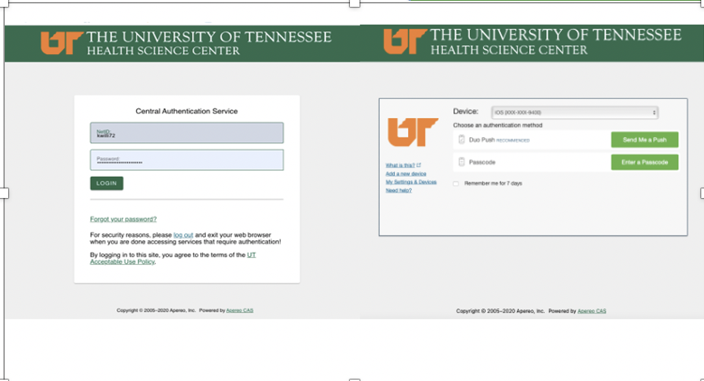
2022
Revised: May 5, 2022

Table of Contents
Correspondence under Study Assistant (for investigators/coordinators) 3
Viewing Correspondence 3
Sending Correspondence 5
Responding to Correspondence 8
Adding Additional Recipients 10
Correspondence under IRB Assistant (for Board members) 11
Issuing Correspondence 11

Correspondence under Study Assistant (for investigators/coordinators)

Viewing Correspondence
- To view correspondence in iMedRIS, on the top left side of your screen, under the My Workspaces tab, hover over/highlight Study, then click on View and Manage My Studies. Note that if you are already in the Study tab, you can also click View and Manage My Studies under the Featured Project Operations section at the top of the page.
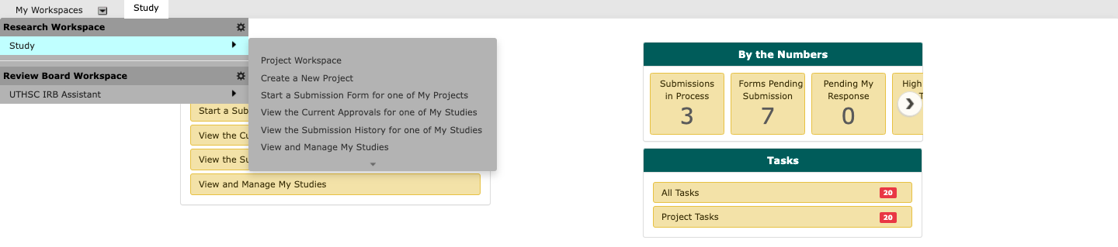

OR
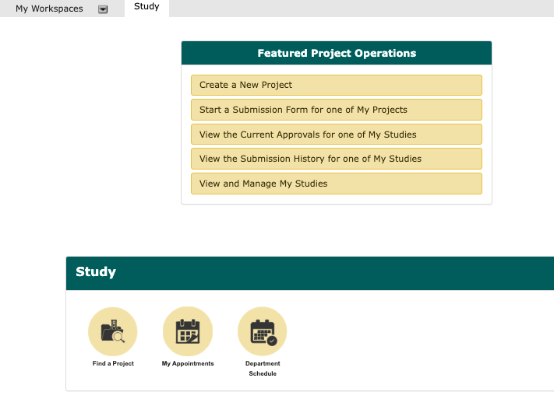

- You will see your list of studies/projects. Click to Open the study you wish to view.

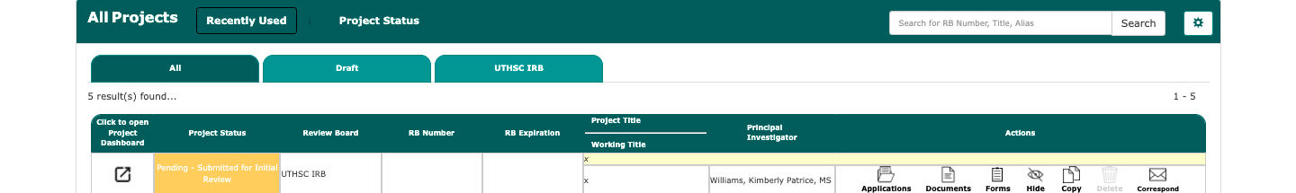

- This will take you to the Submissions screen. Click Project Correspondence.

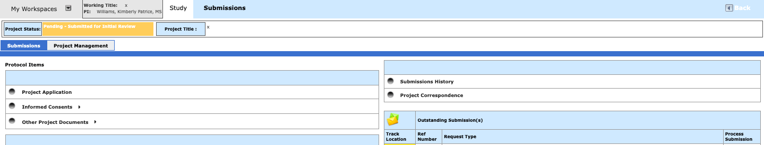

- On the Project Correspondence screen, click the Paper/Pencil icon to read an email message.
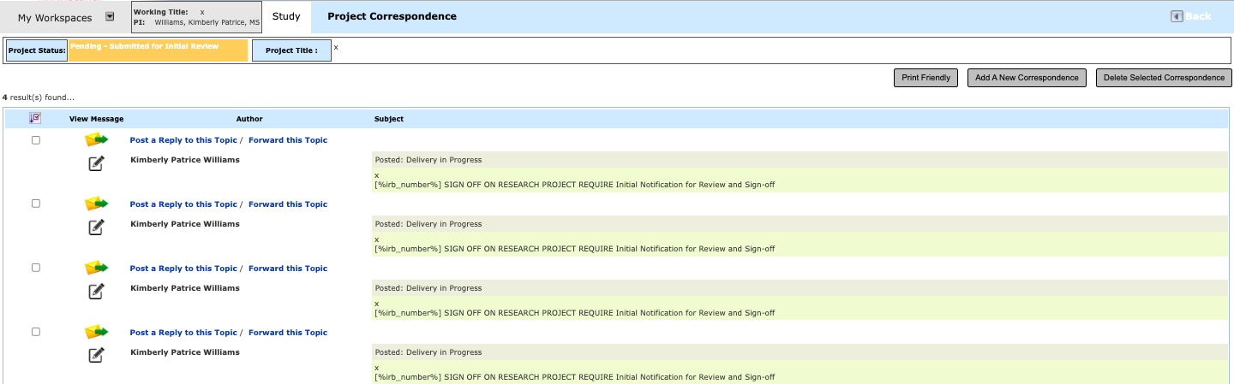

Correspondence in iMedRIS will appear as follows.

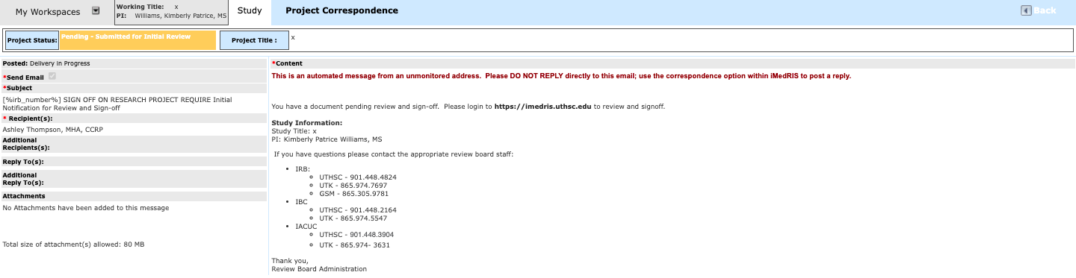

Sending Correspondence

- To send a correspondence, under the My Workspaces tab, hover over/highlight Study, then click on View and Manage My Studies. Note that if you are already in the Study tab, you can also click View and Manage My Studies under the Featured Project Operations section at the top of the page.

OR

- You will see your list of studies/projects. Click to Open the study you wish to view.

- This will take you to the Submissions screen. Click Project Correspondence.

- On the Project Correspondence screen, click Add a New Correspondence.

- Next, on the left side of the screen, in the text box, type in the Subject of the email.
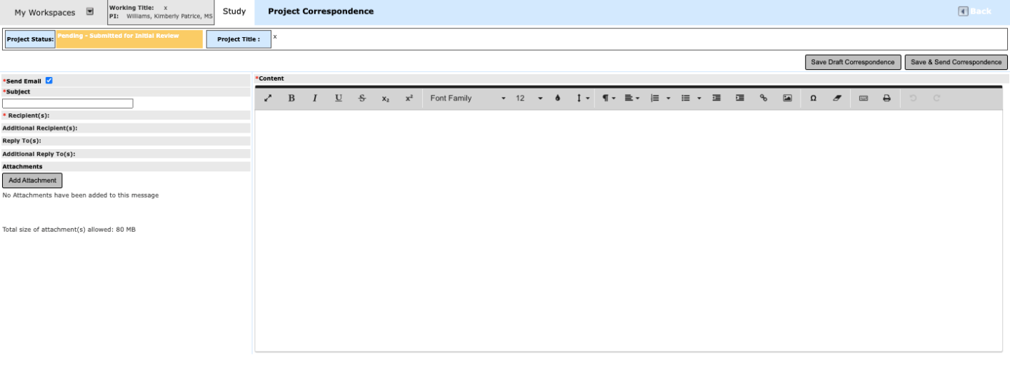

- Next, click Recipients.
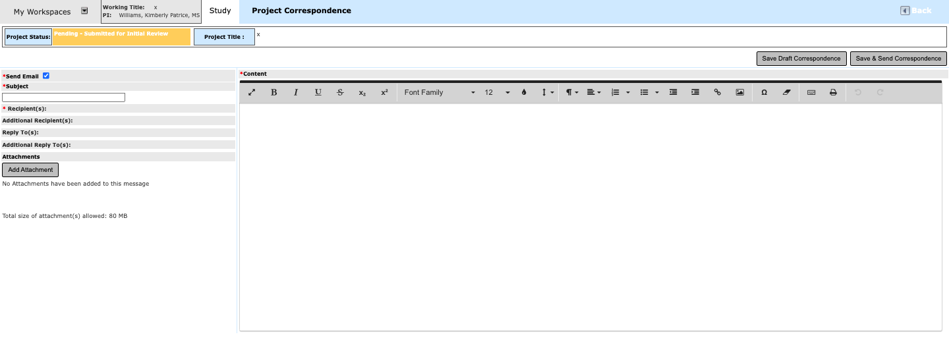
On Correspondence Contact screen, select the name of each person who should receive the correspondence. Be sure to click Save Changes when you are done with your selections.

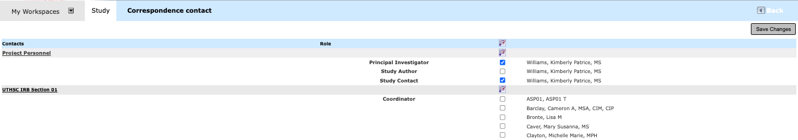

Type your message in the content/text box. Once you have completed your email message, click

Save and Send Correspondence.
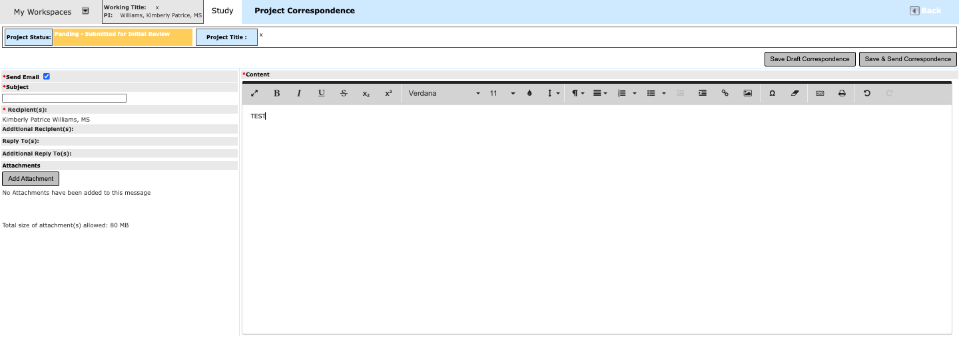

Responding to Correspondence

Note: If you are in your email (Microsoft Outlook or Entourage) viewing the iMedRIS correspondence, do not click the Reply button in these programs. To respond to iMedRIS correspondence, you must open your internet browser, open iMedRIS, and use the Correspondence option on your project’s home page.

- To send a correspondence, under the My Workspaces tab, hover over/highlight Study, then click on View and Manage My Studies. Note that if you are already in the Project Assistant tab, you can also click View and Manage My Studies under the Featured Project Operations section at the top of the page.

OR

- You will see your list of studies/projects. Click to Open the study you wish to view.

- This will take you to the Submissions screen. Click Project Correspondence.

On the Project Correspondence screen, click the envelope icon to respond to an iMedRIS correspondence.

Type your response in the content/text box. Once you have completed your email message, click

Save and Send.

Adding Additional Recipients
If you need to include someone else on the list of recipients of the correspondence who are not listed in the Correspondence Contact screen, click Additional Recipients.

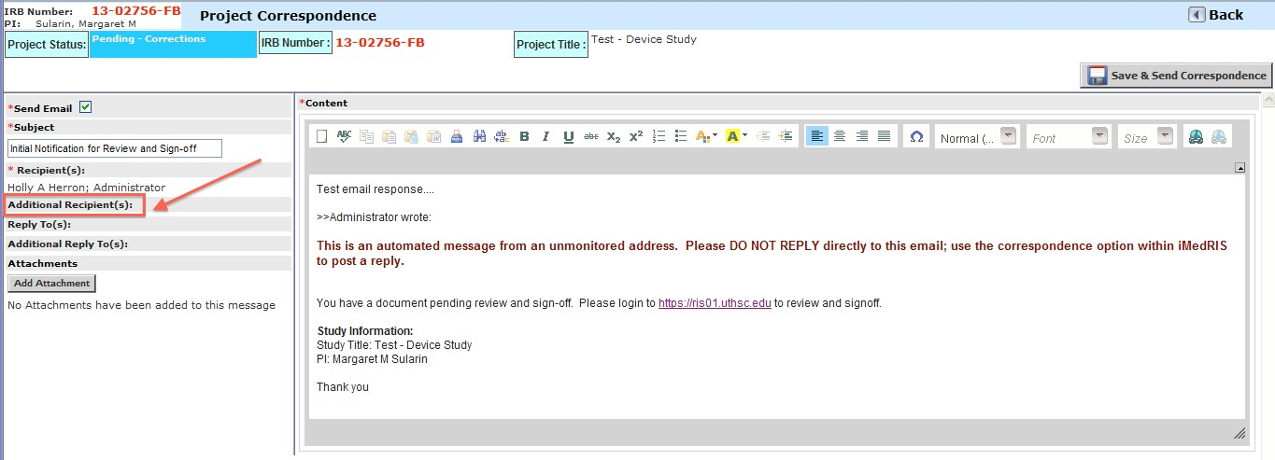

On the Correspondence Additional Contacts screen, click Add a New Contact.

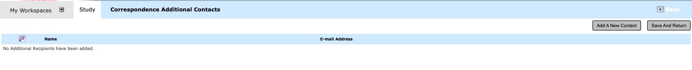

Type in the name and email address of the recipient. If more than one recipient needs to be

added, click Add A New Contact for each additional recipient. Once all of the additional recipients’ names and email addresses have been included, click Save and Return.

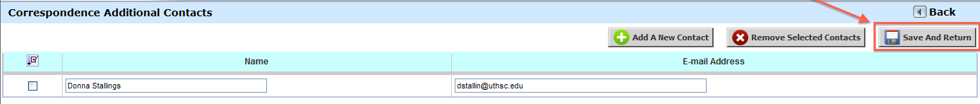

Once you have completed your email message, click Save and Send Correspondence.

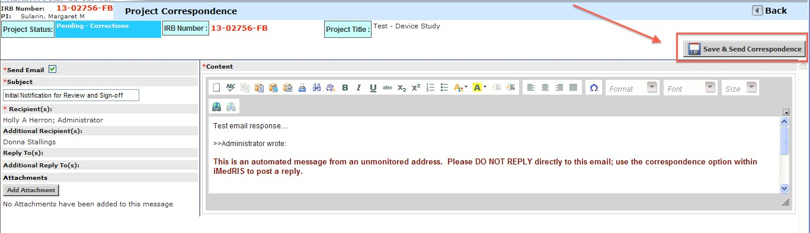

Correspondence under IRB Assistant (for Board members)

Note: If you are a Board member, IRB staff, or a Research Administrative Specialist for one of the IRB affiliated institutions, you will have access to the IRB Assistant tab.

Issuing Correspondence
To issue correspondence in iMedRIS, on the top left side of your screen, under the My Workspaces tab, hover over/highlight UTHSC IRB Assistant, then scroll down to hover over/highlight Correspondence & Notifications, then Click on Correspondence. Note that if you are already in the IRB Assistant tab, you can also click Correspondence under the UTHSC IRB panel at the top of the page.

OR

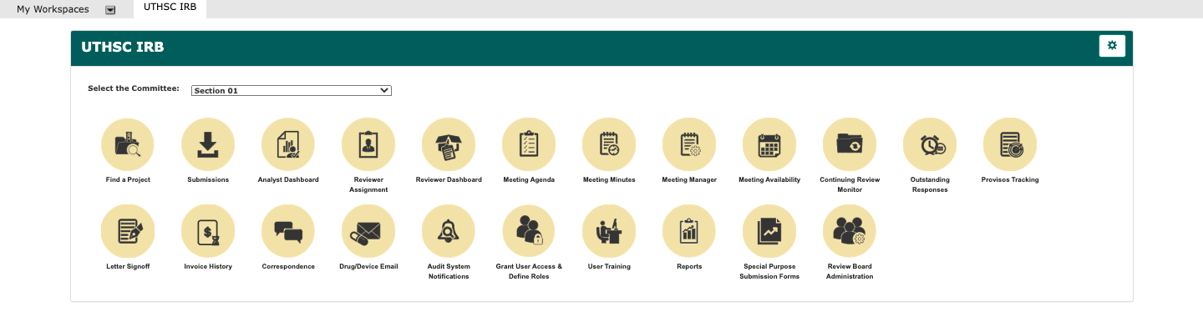

This will take you to the UTHSC IRB – Review Board Correspondence screen. Click Add a New Correspondence.

Next, on the left side of the screen, in the text box, type in the Subject of the email.

Next, click IRB Number to select the appropriate study.

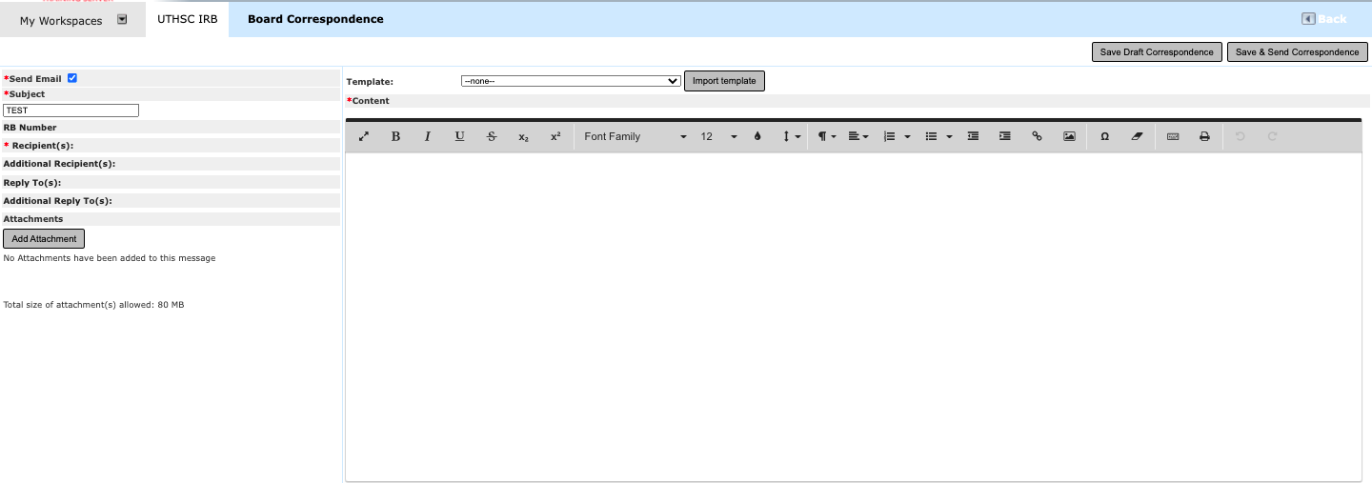

From the Find a Project screen, locate the appropriate study by Sponsor, PI, IRB number, etc., and click Find.

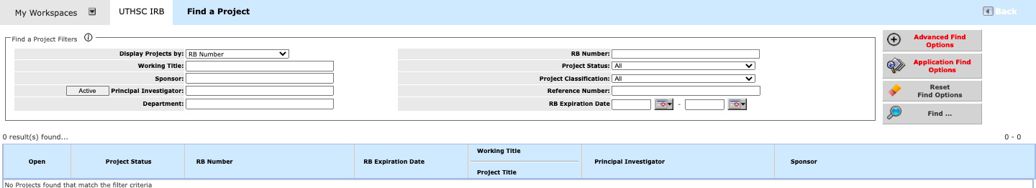

Once you locate the project you wish to reference, click Open on the left side of your screen.

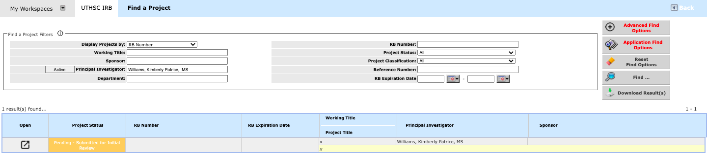

This will return you to the Review Board Correspondence screen, and you will note that the IRB Number box is now populated with the IRB number.

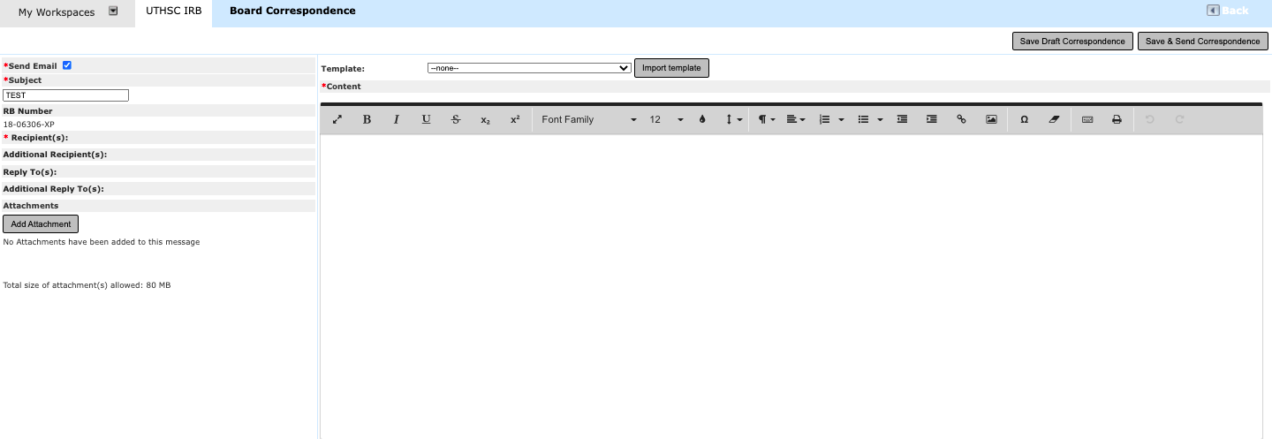

Next, click Recipients.

In Correspondence Contact screen, select the name of each person who should receive the correspondence. Be sure to click Save Changes when you are done with your selections.

You will be returned to the Review Board Correspondence screen.

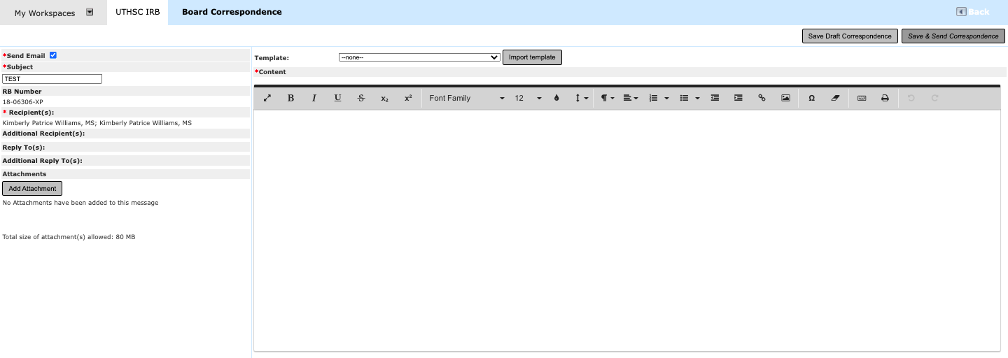

If you need to include someone else on the list of recipients of the correspondence who is not listed in the Correspondence Contact screen, click Additional Recipients.

On the Correspondence Additional Contacts screen, click Add a New Contact.

Type in the name and email address of the recipient. If more than one recipient needs to be
added, click Add A New Contact for each additional recipient. Once all of the additional recipients’ names and email addresses have been included, click Save and Return.

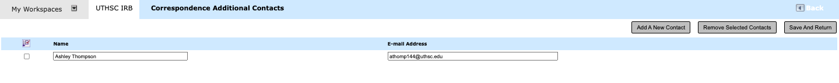

Type your message in the content/text box. Alternatively, use the template option near the top of your screen. To access the template option, click the down arrow, and a drop down menu will appear. Select the appropriate template, and click Import Template

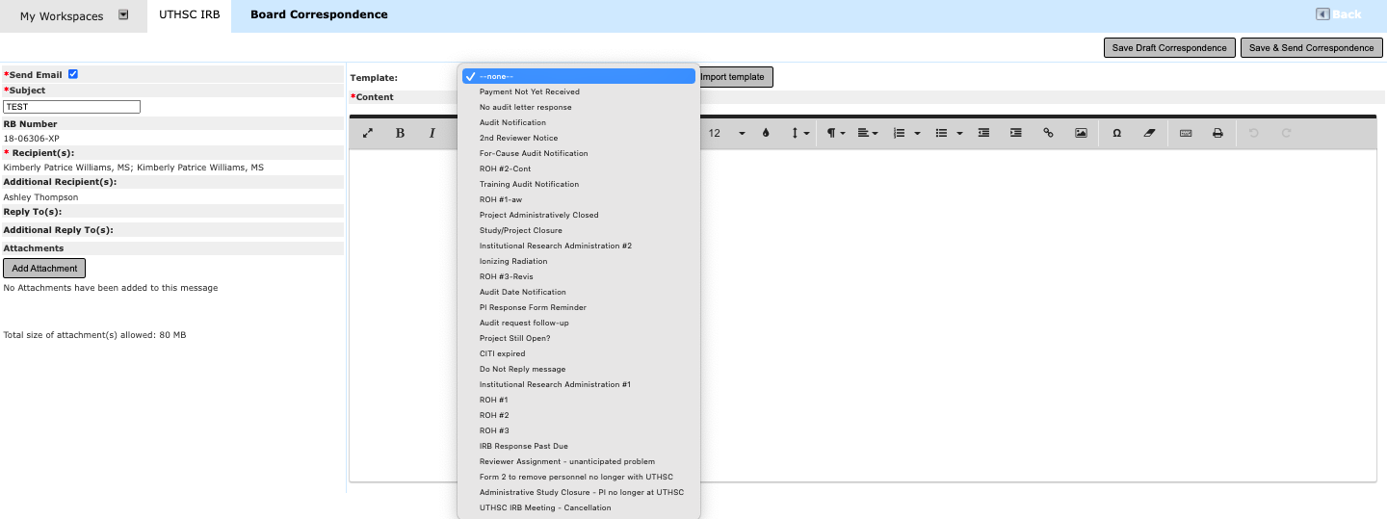

Once the template has been imported, you will receive a text box message. Click Ok.

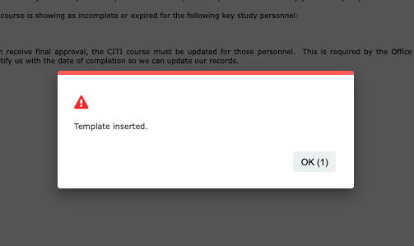

Click Save and Send Correspondence once you have completed your correspondence.

