University of Tennessee Health Science Center
College of Nursing
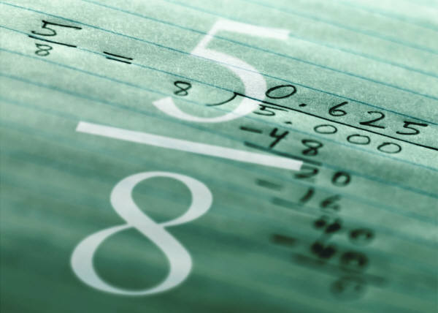
General Dosage Rounding Rules
The UTHSC College of Nursing dosage rounding rules will need to be appropriately applied to all dosage calculation problems. Credit will not be given for answers with incorrect rounding or those failing to adhere to other rules as directed for calculation of dosages.
- Tablets/Capsules – round to the nearest whole tablet. Round up or down depending on the calculated dose i.e.: 1.1 – 1.4 tablets, give 1 tablet; 1.5 – 1.9 tablets, give 2 tablets.
Scored tablets may be broken in half. If scored, tablets should be rounded to the nearest half tablet. Example: 1.45 scored tablets = 1 ½ tablets
*Capsules are not scored.

- Liquid (Oral) – round to the nearest tenth. i.e.: 10.3ml of cough syrup may be given. Pour 10 mL into medicine cup; draw up the 0.3 mL in a 3 mL syringe and add to the medicine cup.

- Liquid (Injectables) – round to the tenth or hundredth (depending on volume).
Milliliters
- Volumes less than 1 - round to the nearest hundredth i.e.: = 0.75mL
- Volumes greater than 1 – round to the nearest tenth i.e.: 1.25mL – 1.3mL
Syringes
- Use a 3 mL syringe for any dose between 1 and 3 mL. Round to the nearest tenth.
- Use a 1 mL (tuberculin) syringe for doses < 1 mL. Round to the nearest hundredth.
- Intravenous (Basic Fluid/Piggyback Infusions) – round to the nearest whole number. This applies to flow rates calculated in drops/min or mL/hr i.e.: 15.4 drops/min = 15 drops/min

- Intravenous (Medicated/Dose-Based Flow Rates) – round to the nearest tenth. i.e.: 0.45mg/min = 0.5mg/min, 0.69 milliUnits/min = 0.7 milliUnits/min

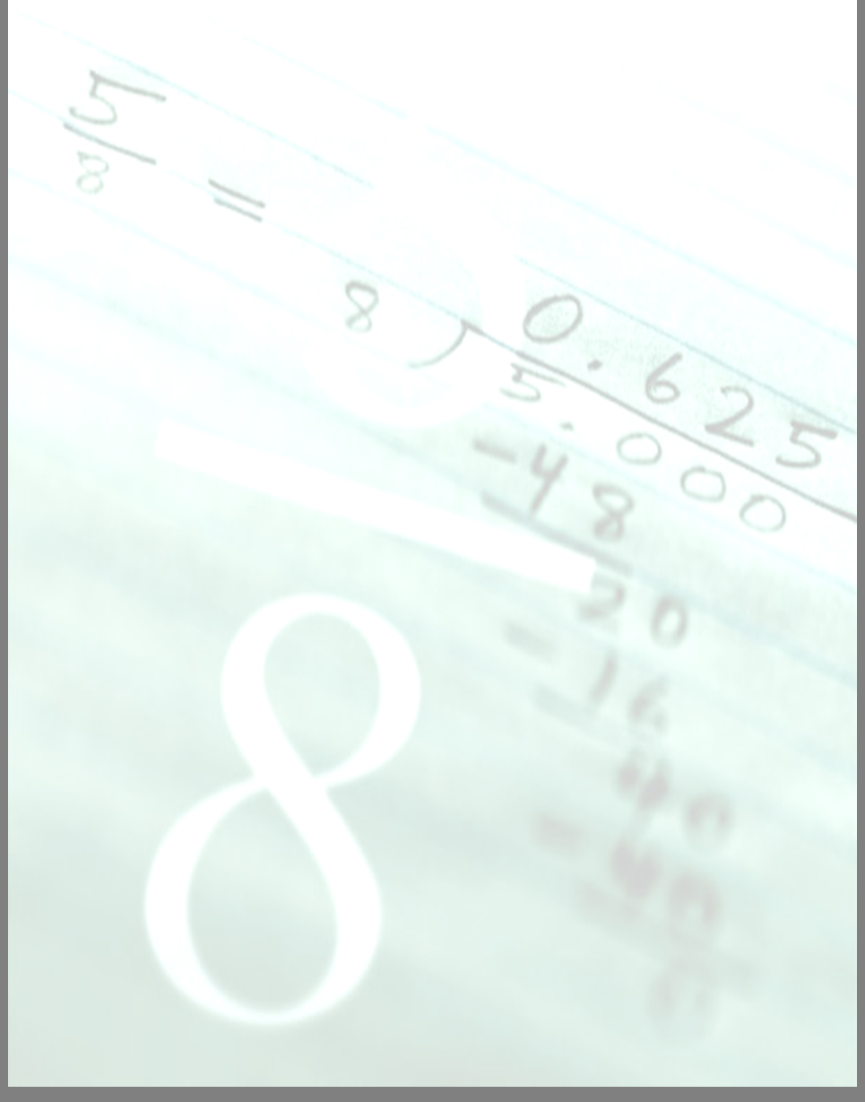
- Pediatrics – use the same rounding rules applied to adult medications depending on type.

Calculating Dosage
- Round to the nearest tenth. i.e.: 5.35mg = 5.4mg
Calculating Weight
- Kilograms – round to the nearest tenth.
- Body Surface Area – round to the nearest hundredth.
Other Rules
To prevent error, all calculations must have:
- Leading zeros – If the calculated dose is a decimal number that is not preceded by a whole number, a zero must precede the decimal point.
Example:
Answer = 0.75 mL (correct); Answer = .75 mL (incorrect)

- No trailing zeros - If the calculated dose is a decimal number that ends in zero, the zero holding no value must be omitted.
Example:
Answer = 1.5 mL (correct); Answer = 1.50 mL (incorrect)

- Labels – All calculated doses must be labeled with proper units of measure.
Example:
Answer = 7.5 mcg (correct); Answer = 7.5 (incorrect)

