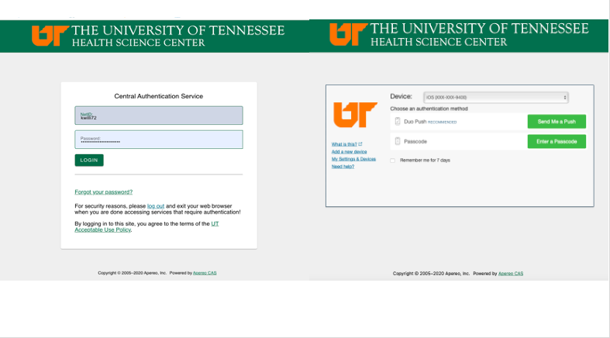
Routing, Workflow Tracking, & Signoff Guide
Guide

2022
Revised: March 6, 2022
Table of Contents
Routing for Signatures 3
Workflow Tracking 7
Signoff 11

Routing for Signatures

- After clicking Signoff and Submit for any type of submission, you will be asked if the submission requires additional routing for approval.

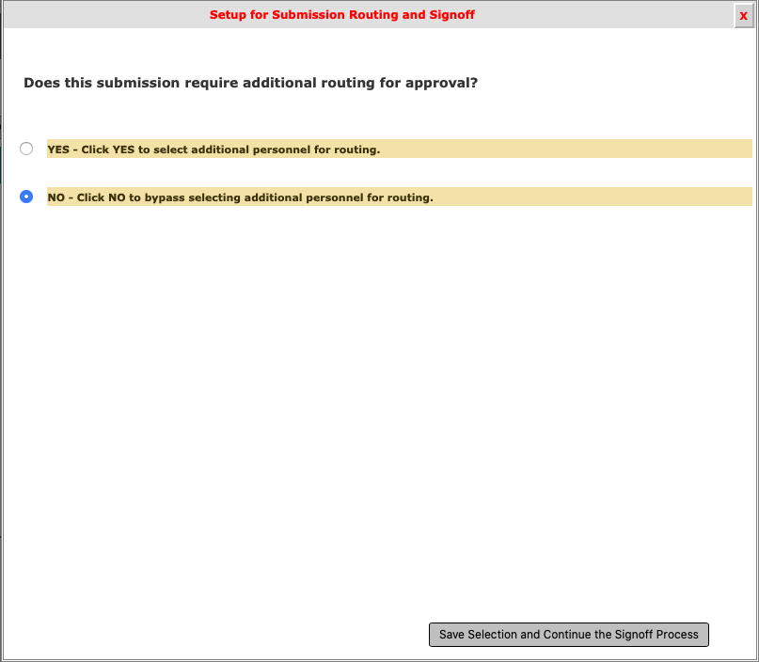

- Change the answer to Yes if you have anyone in addition to the principal investigator who must sign off on the submission. Please see the chart below for required signatures.
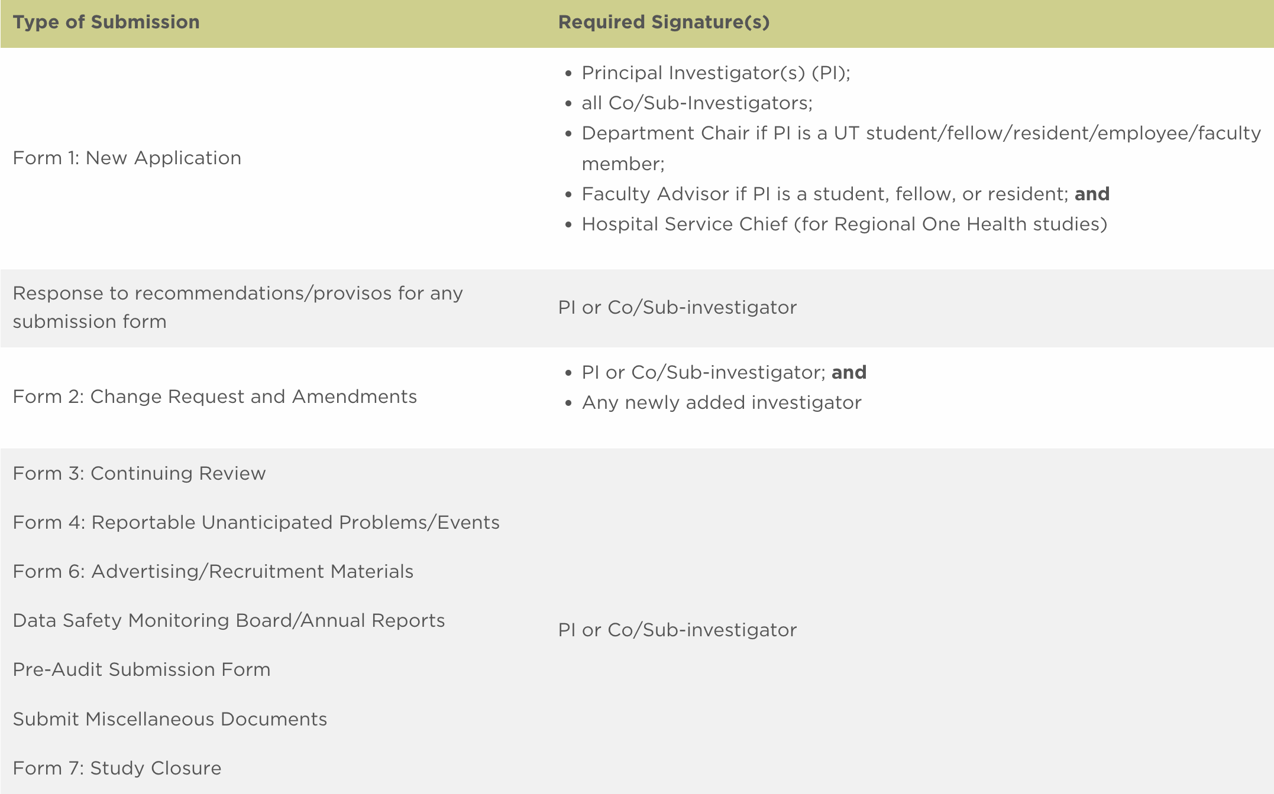
- If you need to send to anyone besides the principal investigator to sign off, check Yes and then click Save Selection and Continue the Signoff Process button in the bottom right corner.

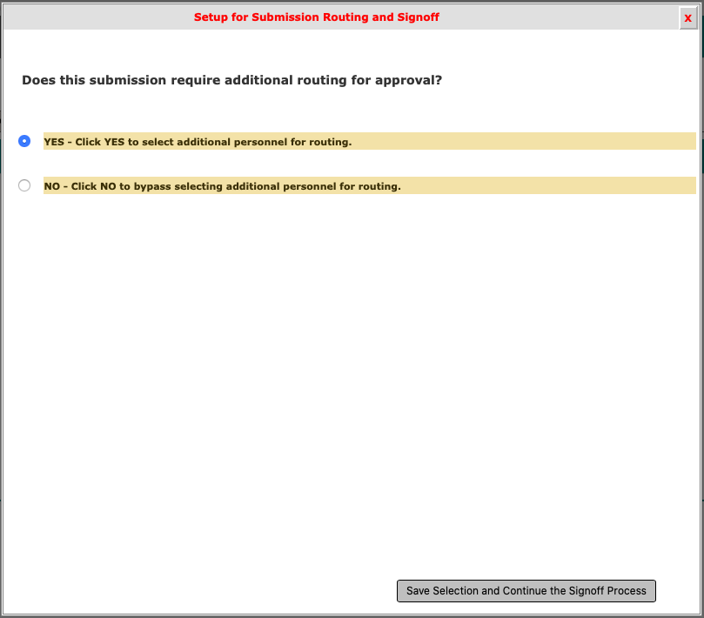

- Once you click Save Selection and Continue the Signoff Process button in the bottom right corner, all investigators, department chairs, and hospital chiefs will appear. Make sure you check the box beside the people who need to sign off so that they are included in the routing for signatures. If there is someone that you entered in Section 3.0 who does not appear on the sign-off list, you may click the Add Additional Personnel to the Routing List button. Note: if some investigator names do not appear, you did not include them in section 3.0 of your application, so you must go back and revise your study application.

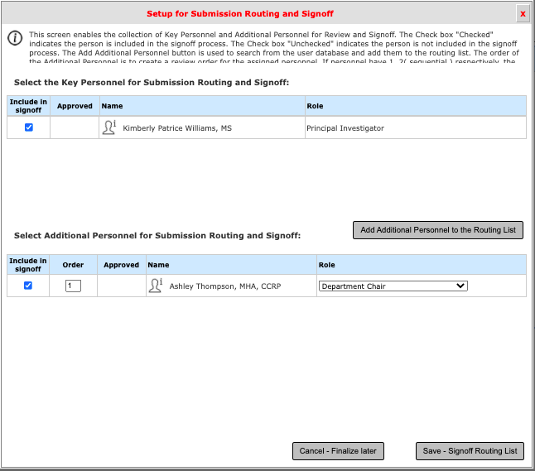

- Once you click Save-Signoff Routing List, you will be asked to verify that the list above represents the finalize Personnel for review and sign-off. If the list is correct, click Yes and then click Save-Start Signoff Routing. If not, click No and select Cancel-Finalize Later or Go Back to Make Changes.

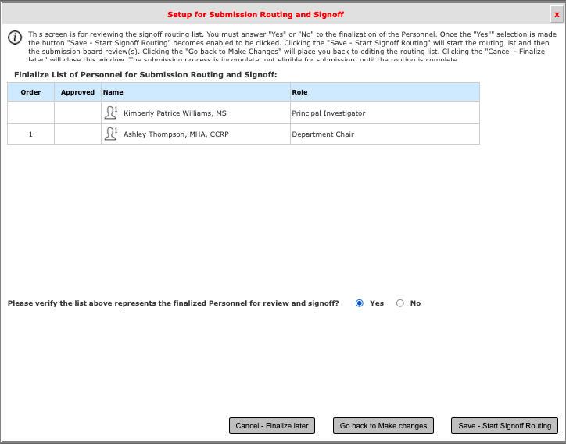

- You will then see the screen below. You may click OK or wait until the 10-second countdown ends, which will then take you to the PI Responsibilities screen.

- Review the PI Responsibilities and select Approve and then Save-Signoff.

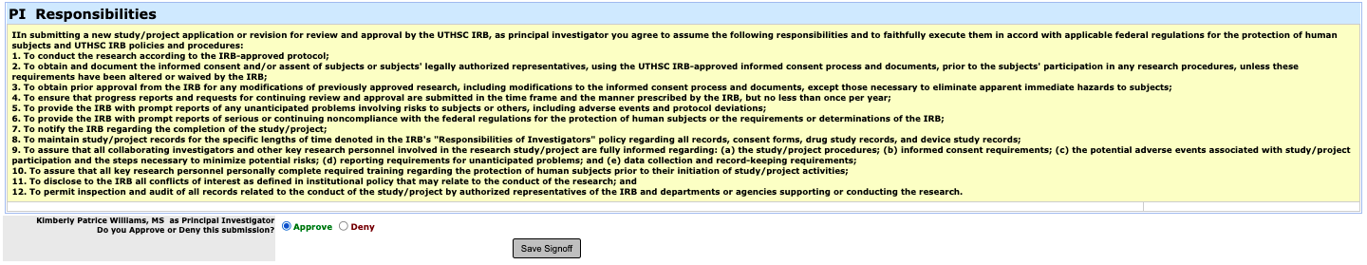

Workflow Tracking

- Once you save after saying Yes, you will be routed back to the Study Workspace. This page allows you to see your submissions. To track your submission, scroll to the section All Projects. Click on the arrow icon to view the project dashboard.

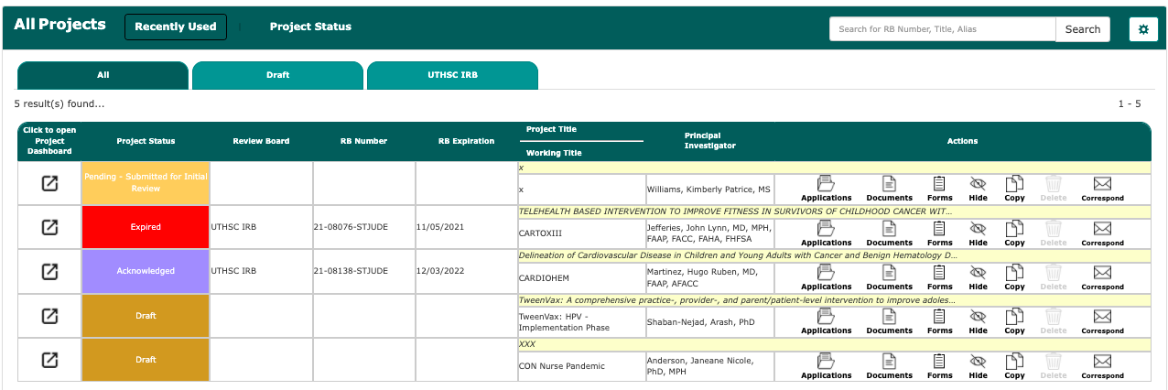

- You can click on magnifying glass icon in the green Waiting for Signoffs box to get to the Workflow Tracking page to see where your submission is in the electronic process, who has still not signed off, and whether the IRB has received your submission.

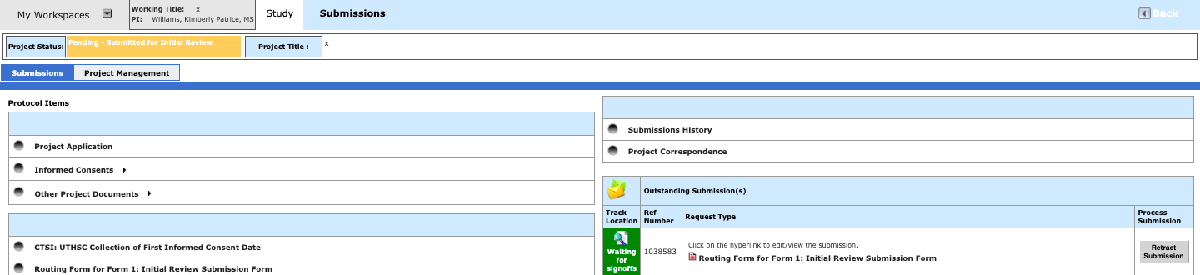

- Click the orange button entitled Pre-Submission followed by the “+” next to the words Pre-Submission on the left.
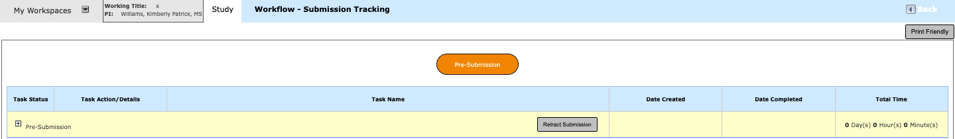

- Below, the Principal Investigator, Kim, has signed, indicated by the View Signoff box in the Task Actions/Details column and the words Completed to the left of this box. Sign-off is still pending for Mary Susana Caver, Faculty Advisor, indicated by the Pending Signoff box in the Task Actions/Details column. Note that the department chair is not listed on this page. In addition, the IRB will NOT receive the submission until all persons in the routing assignment list, including the department chair and/or hospital chief have signed.. If you want to change your routing assignment list, you can click on the Modify Signoff Routing List icon in the Task Action/Details column and re-save your list

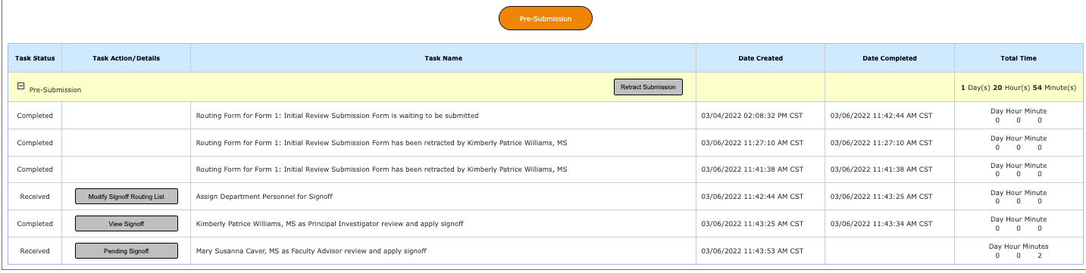

- If you want to change your routing assignment list, you can click on the Modify Signoff Routing List icon in the Task Action/Details column and re-save your list]

- After the submission has been routed to the IRB, the project status will appear on the Study Workspace page. You can view what step your submission is in the pre-review process by clicking the Steps icon in the Actions column.
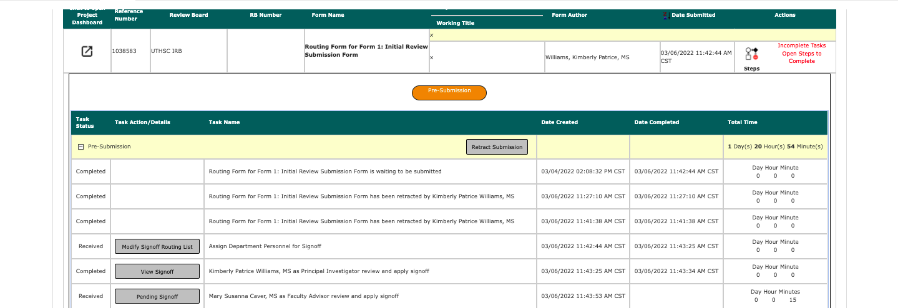

- After the IRB has received your submission, the Outstanding Submission information will no longer be available on your study’s home page.
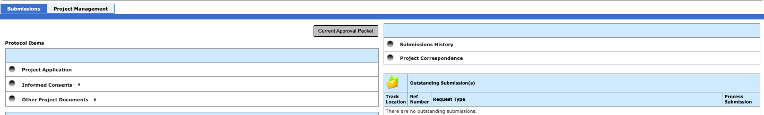

- You must go to your Submission History to get to the Workflow Tracking page

- Then, click on the Track Location button.

- You can then see the status of your submission again. You can also see who was assigned as your analyst in the IRB office by clicking the highlighted button that describes where your submission is in the review process. If you have questions about your project, call and ask for this person as she will be the most familiar with your project.

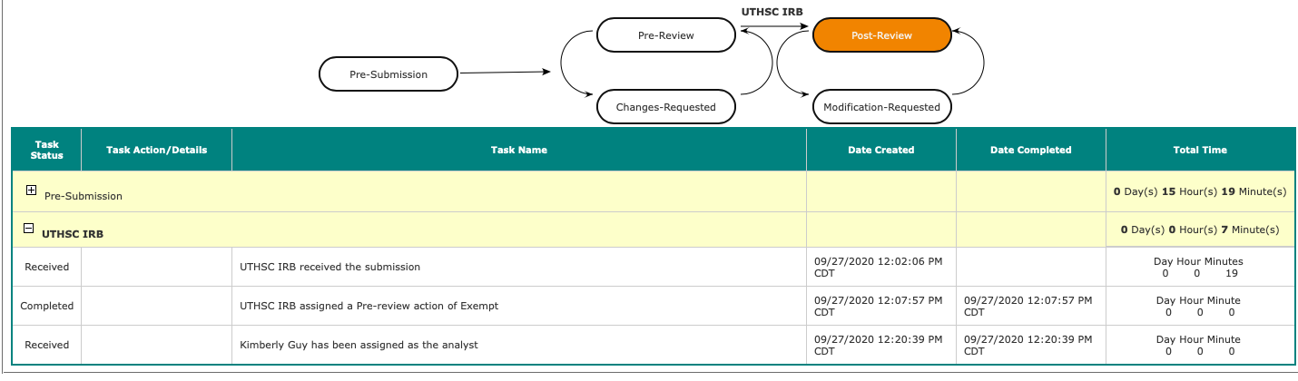

- If you log out of iMedRIS and want to find your project again, log into iMedRIS. On your home screen, under My Workspaces tab on the top left of the screen, hover over/highlight Study and then click on View and Manage My Studies. Note that if you are already in the Study tab, you can also click View and Manage My Studies under the Featured Project Operations section at the top of the page.

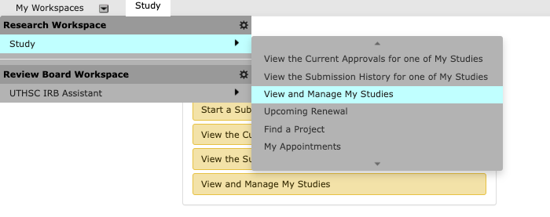

OR

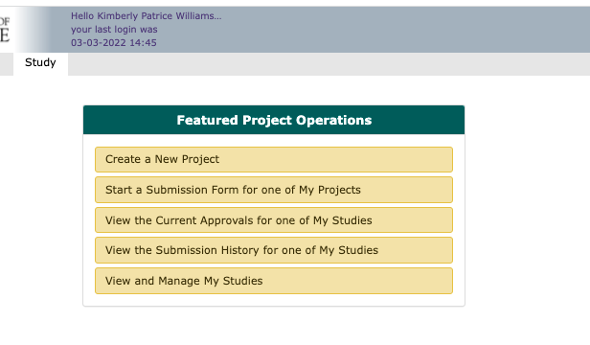
- You will see your list of studies/projects. Click to open the study you wish to view.

- This will take you to the Submissions screen. Click Submission History and then Track Location as described above.

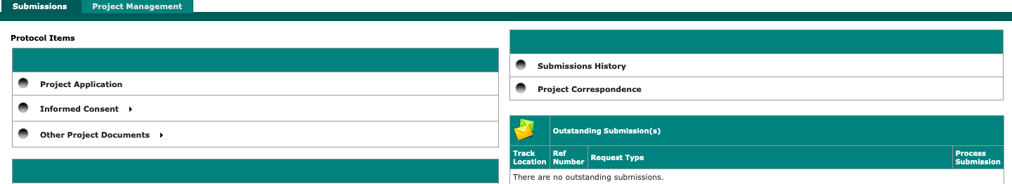

Signoff

- If you are the principal investigator or a co-/sub-investigator submitting to the IRB, you will be asked to sign off on the submission after you finish the routing assignment list.

- Click “Approve” if all of the submission components accurately represent your project, and click Save Signoff.

- If you did not submit your project’s form to the IRB, but you need to sign off, you will have a Submission Routing Signoff notice on your iMedRIS home page under the tasks panel.

- To directly sign off from the task panel, click the Open icon next to the Submission Routing Signoff.

To see more information about the study (such as project status, project title, Principal Investigator, etc.), click the study tasks tab. You will then have the following view:

You will still click the Open icon next to the Submission Routing Signoff.

- You will see a page similar to this with your project’s submission components:

- Click “Approve” if all of the submission components accurately represent your project; enter your NetID and password; and click Save Signoff.

